The Incoherence of Atheism and Scientism

Abstract
Atheism and scientism both claim to rely solely on empirical science, yet this strict materialism faces serious challenges. Modern physics reveals that gravity, light, and quantum phenomena defy simple explanation: for example, we do not know what gravity “is” in any fundamental way[1], and quantum mechanics describes a counter-intuitive reality that few agree how to interpret[2]. Scientism (the view that only science can answer questions) insists on limiting belief to observable phenomena[3], but critics point out this stance is self-refuting[4]: science itself cannot prove that it is the only path to knowledge, nor can it account for meanings or purposes. Many atheist thinkers even declare the universe a purposeless accident[5], yet the astonishing fine-tuning and mysterious complexity uncovered by science seem implausible if everything is random. This essay reviews philosophical critiques of scientism[3][4] and highlights how science’s own limits (e.g. the nature of gravity or light) make an exclusively atheistic/materialistic worldview difficult to sustain[6][7]. The conclusion urges intellectual humility in the face of these mysteries.

Scientism and Its Limits
Scientism is the doctrine that science is the ultimate arbiter of truth and the only legitimate knowledge. As one critic summarizes, “scientism is not science. It is an interpretation of science resulting from a simple, misplaced optimism in the scientific method”[3]. In practice, scientism often includes theses like these[8]:
- T1: The only kind of knowledge we can have is scientific knowledge[8].
- T2: The only things that exist are those that science can discover[8].
- T3: Science alone can answer our moral questions and replace traditional ethics[8].
- T4: Science alone can answer our existential questions and replace traditional religion[8].
Philosophers note that T1–T2 are self-refuting: science cannot by its methods prove that science is the only path to truth, or that reality is nothing but what it observes[4]. In other words, scientism already takes for granted a metaphysical belief (that only material facts exist) that science itself cannot verify[4]. Pigliucci similarly argues that scientism “assumes a totalizing attitude that regards science as the ultimate standard,” which is philosophically unsound[9]. Indeed, Peter Atkins (a prominent atheist chemist) went so far as to say “Science is the only path to understanding… [religion] would be contaminated rather than enriched by any alliance”[3] – a stance that exemplifies scientism’s imperialism. Critics warn that this arrogance leads scientism to do disservice to science itself by neglecting its philosophical assumptions, and even to atheism by dismissing useful philosophical arguments[9][10].

Unsolved Mysteries: Gravity and Light
Even fundamental physical concepts elude simple scientific explanation. Gravity, for example, is well-described mathematically, but its essence remains unknown. As NASA explains, “we do not know what gravity ‘is’ in any fundamental way – we only know how it behaves,” whether as a field or via hypothetical gravitons[1]. Newton himself admitted in Principia that he could “assign[] no cause” for gravity’s power, famously saying “I have not been able to discover the cause of those properties of gravity… and I frame no hypotheses”[6]. In other words, Newton recognized that science can describe gravity’s effects (the apple falling, planetary orbits) without revealing why gravity exists. Modern puzzles compound this mystery: astronomical observations show the universe’s expansion is accelerating, a phenomenon commonly attributed to dark energy[11]. Scientists still debate whether dark energy is a new substance or a clue that gravity itself must be generalized. (Indeed, recent work suggests that a modified “Finsler” gravity might explain cosmic acceleration without any dark energy at all[11]【45†】.)
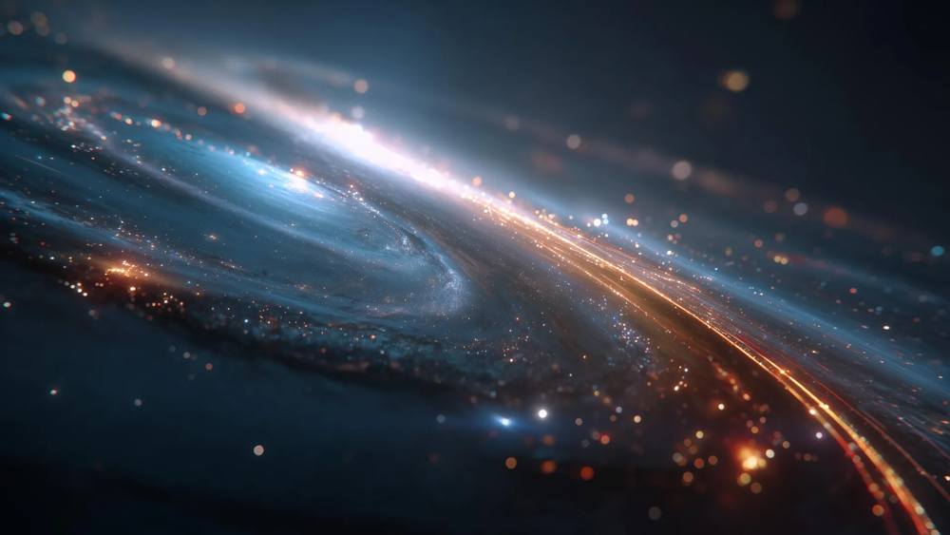
Figure: Artistic visualization of the expanding cosmos (accelerating universe). The cause of this acceleration is unknown; dark energy was posited to explain it, but alternative gravity theories are being explored[11].
Similarly, the nature of light is bizarre. Einstein’s work showed that light exhibits both wave-like and particle-like behavior (the wave-particle duality)[12]. Light can knock electrons out of atoms like tiny bullets, yet also produce interference patterns like a wave. As Marcelo Gleiser notes, light is “the fastest thing in the cosmos” and “carries with it the secrets of reality in ways we cannot completely understand”[7]. In short, even though we can calculate with Maxwell’s equations or quantum electrodynamics, we still lack an intuitive grasp of what light is. This echoes Gernsback’s early 20th‑century observation that we may “know nothing at all” about the ultimate nature of electricity, light, or even matter[13].
In view of these mysteries, insisting that only the observable is real becomes problematic. One recent theory even proposes that gravity is not a fundamental force at all but an emergent effect of quantum interactions between matter and light[14][15]. In this view, the exchange of photons “stitches” spacetime itself and produces what we perceive as gravitational attraction[15][16]. Remarkably, this approach can recover Einstein’s predictions (orbits, gravitational pull) and even explain dark-matter and dark-energy anomalies from the thermodynamics of ordinary matter[17][18]. The need for such radical models underscores how much we still do not understand. Whether or not these specific ideas prove true, they highlight that gravity and light remain deep puzzles, not fully captured by present theories. To insist (as scientism does) that only our current formulas are trustworthy truths ignores the glaring unknowns in their foundation[6][1].

Quantum Mechanics and the Limits of Observation
Quantum physics deepens the puzzle. Its predictions are stunningly accurate, yet its interpretation defies commonsense. As Sean Carroll observes, quantum mechanics presents a “counter-intuitive reality in which the act of observation influences what is observed — and few can agree on what that means”[2]. Experiments with entanglement, superposition, and uncertainty reveal behavior that seems almost magical from a classical perspective.

Figure: A fractal generated from a 5‑qubit quantum system (image by Wiktor Mazin). Such complex patterns illustrate how even simple quantum states can exhibit mind-bending structure, underscoring the idea that quantum reality “carries…the secrets of reality in ways we cannot completely understand”[7][2].
In fact, even the founders of quantum theory balked at its mystery. Einstein famously quipped that quantum mechanics “hardly brings us closer to the secret of the Old One”[19], and Bohm noted that opposing (classically “wrong”) explanations can both be deep truths in quantum physics[20]. If physics is willing to entertain such puzzles, it is extraordinary for atheists to conclude that all this structure and apparent fine-tuning is merely accidental. Many scientists and philosophers have pointed out that interpreting quantum randomness as brute fact is a leap of faith. As one commentator wryly remarks, insisting the universe is “blind, pitiless indifference”[5] in the face of quantum weirdness is both statistically and metaphysically bold.
Ultimately, the bizarre findings of quantum mechanics show that science has limits: it predicts outcomes, but its own methodology cannot answer why there is order rather than chaos. The uncertainty principle, wavefunctions, and measurement problem remain open questions. An absolutist scientism that claims only observable data matters cannot easily accommodate these ambiguous aspects of theory[2][12].

Philosophical Reflection: Essence, Cause, and Meaning
Beyond the physics, there are deeper philosophical issues. Atheism – defined simply as disbelief in gods – often goes hand-in-hand with a materialist claim that everything arose by chance. The most vigorous atheist writers admit this worldview: Richard Dawkins, for example, writes that the universe appears to have “no design, no purpose” and is “nothing but blind, pitiless indifference”[5]. If gravity, light, and life itself have no underlying reason, then scientific discovery yields no ultimate meaning. Critics argue this is incoherent. How can a purely material universe produce reason, morality, or consciousness? Some point out that Darwin worried over similar questions: the philosopher Peter A. Clarke summarizes Darwin’s admission of a “horrid doubt” whether human mental faculties could be trusted if they were only the product of non-rational natural selection[21]. (Darwin himself wrote that doubt arises if one assumes our convictions have “any value or trustworthiness” under a blind evolutionary process[22].) In other words, an atheistic account undercuts the very rationality needed to claim truth.
At a minimum, rejecting all metaphysical causes invites paradox. Even positing something like panpsychism (the idea that mind is fundamental) was described as a desperate “metaphysical hail Mary” for atheists trying to explain consciousness[23]. Aliens “all the way down” (an infinite regress of intelligent matter) leads to dead ends, so the atheist is left with a brute emergence of reason from purposeless atoms – a transformation arguably more miraculous than any traditional creation story[24].
Moreover, atheism and scientism typically deny purpose or essence. Philosophers from Aristotle to Aquinas argued that everything requires a first cause or reason for its nature. Science, being rooted in observation, cannot itself justify ultimate causation. As one philosopher notes, claiming that only science can know truth is already a metaphysical assumption[4]. Indeed, St. Thomas and others stressed the “why” questions that science leaves unanswered. Newton’s own attitude was humble: he asserted that “to us it is enough that gravity does really exist, and acts according to the laws which we have explained”[6], refusing to speculate beyond what phenomena show. In this spirit, rejecting any purpose or cause a priori – as atheistic scientism does – seems premature.
Finally, consider the fine-tuning of physics. The exact masses of particles, the strengths of forces, and initial conditions of the universe lie in extremely narrow ranges that allow stars, chemistry, and life. While one may invoke chance or a multiverse, this again goes beyond pure empiricism and into interpretation. Atheism-as-accident cannot scientifically prove that life-permitting constants are merely lucky; indeed, many scientists (even some agnostic ones) marvel that “the universe is set up to produce us” at all. To assert otherwise is to ignore what the data seem to suggest: that nature’s constants are highly non-random. Of course, science can only report these facts, but the philosophical move to call them meaningless chance is not dictated by observation – it is an extra-scientific interpretation.
In summary, the philosophical essence of atheism and scientism collapses under scrutiny. They either deny what science itself presupposes (such as logic, uniform laws, or meaning) or ignore the existential implications of scientific findings. Critics argue that insisting on a purely material accident is incoherent: it attempts to use reason while denying its ultimate grounding[21], and it treats the awe-inspiring complexity revealed by physics as if it had no deeper explanation[5][7].

Thematic Epilogue
At the close of this investigation, we are reminded of the limits of our understanding. Even the great Albert Einstein admitted that our best theories “hardly bring us closer to the secret of the Old One”[19]. In other words, despite its triumphs, science has not resolved the ultimate why of reality. True intellectual humility dictates that we remain open to mystery. As Newton himself suggested, it was sufficient for him that gravity worked according to discoverable laws[6] – he did not insist on a full materialist explanation for its origin.
The cosmos and its laws inspire awe rather than smug certainty. To claim that everything is merely a random accident strikes some as a refusal to acknowledge the meaningful patterns we see. Meanwhile, to invoke only what is empirically observable as real is to ignore that even science relies on unproven assumptions (like the uniformity of nature) and cannot observe itself as self-explanatory[4].
In the end, the incoherence of strict atheistic scientism invites us to a truer humility: that scientific knowledge and metaphysical insight are both facets of the human quest. The beauty of a quantum fractal or the mystery of accelerating space (as in the figures above) calls not for arrogance but for wonder. Perhaps genuine progress comes from allowing science to inform our worldview and philosophy or theology to ask questions that science alone cannot settle. Only then can we reconcile the marvels of gravity, light, and life with a coherent understanding of meaning.
Sources: This analysis draws on critiques of scientism and atheism[3][4][9][10], on modern physics literature about gravity, light and quantum mechanics[1][25][14][2], and on historical reflections by scientists like Newton and Einstein[6][19]. These sources illustrate how even cutting-edge science acknowledges deep unknowns that an exclusively materialist ideology struggles to address.

[1] What is gravity?
https://starchild.gsfc.nasa.gov/docs/StarChild/questions/question30.html
[2] Why even physicists still don’t understand quantum theory 100 years on
https://www.nature.com/articles/d41586-025-00296-9?error=cookies_not_supported&code=72ff3ef4-7f6f-4469-a86d-3b19b755972c
[3] [4] [5] [8] Reductionism, Scientism, and Pantheism in New Atheist Thought - Article - BioLogos
https://biologos.org/articles/reductionism-scientism-and-pantheism-in-new-atheist-thought
[6] Hypotheses (Non) Fingo | Issue 88 | Philosophy Now
https://philosophynow.org/issues/88/Hypotheses_Non_Fingo
[7] [12] [25] The paradox of light goes beyond wave-particle duality - Big Think
https://bigthink.com/13-8/quantum-nature-of-light/
[9] [10] New Atheism and the Scientistic Turn in the Atheism Movement
https://philpapers.org/go.pl?id=PIGNAA&proxyId=&u=https%3A%2F%2Fphilpapers.org%2Farchive%2FPIGNAA.pdf
[11] A new theory of gravity could explain cosmic acceleration without dark energy | ScienceDaily
https://www.sciencedaily.com/releases/2026/01/260110211221.htm
[13] Page:Amazing Stories-1928-08.djvu/7 - Wikisource, the free online library
https://en.wikisource.org/wiki/Page:Amazing_Stories-1928-08.djvu/7
[14] [15] [16] [17] [18] New theory suggests gravity is not a fundamental force - Advanced Science News
https://www.advancedsciencenews.com/new-theory-suggests-gravity-is-not-a-fundamental-force/
[19] What Einstein meant by ‘God does not play dice’ | Aeon Ideas
https://aeon.co/ideas/what-einstein-meant-by-god-does-not-play-dice
[20] fhi.mpg.de
https://www.fhi.mpg.de/963055/aphorisms9.pdf
[21] [22] [23] [24] The Philosophical and Scientific Incoherence of Atheism: An Exhaustive Analysis of Existential, Conscious, and Rational Deficits – The Glorious Quran and Science
https://thequran.love/2025/12/25/the-philosophical-and-scientific-incoherence-of-atheism-an-exhaustive-analysis-of-existential-conscious-and-rational-deficits-2/

