Calcium: From Cosmic Origins to Bones – A Journey of Providential Design

Abstract
Calcium – the element that fortifies our bones and teeth – was forged in the hearts of ancient stars billions of years ago. Through spectacular supernova explosions, this vital element was scattered across the cosmos and eventually incorporated into planet Earth[1][2]. Eons later, life on Earth evolved to harness calcium for building hard structures: from the first mineralized shells in the sea to the sturdy bones of vertebrates. Today, calcium’s journey continues as it nourishes our bodies through diet, especially via the milk that mammals produce. This article explores how calcium was made and delivered to our world, why it is so crucial for our skeletal system, and how it reaches us through food – all framed as part of God’s amazing providence. Blending cutting-edge science with theological reflection (with a special emphasis on Islamic teachings), we see how cosmology, evolution, and biology intertwine in a grand narrative that many believers view as evidence of a purposeful Divine design.

Calcium in the Cosmos: Forged in Star Furnaces
It is a staggering fact of modern science that every atom of calcium in our bodies was created in a star. In the very early universe (the Big Bang), only the lightest elements like hydrogen and helium formed. Heavier elements – including life-essential elements such as carbon, oxygen, iron, and calcium – were synthesized later inside stars. As famed astronomer Carl Sagan said, “we are made of star stuff,” and astrophysics confirms this. Massive stars act as elemental factories, fusing lighter atoms into heavier ones in their hot cores[3]. Calcium, for instance, is produced during the late stages of a heavy star’s life when helium and other elements fuse in its core. Eventually, these stars reach a crisis point; when fusion can no longer sustain them, they die in cataclysmic explosions known as supernovae. In those final moments, an immense burst of energy creates and ejects even more heavy elements. Scientists estimate that about half of all the calcium in the universe – including the calcium in our teeth and bones – was created by dying stars that exploded as supernovae, scattering calcium-rich debris into space[2].
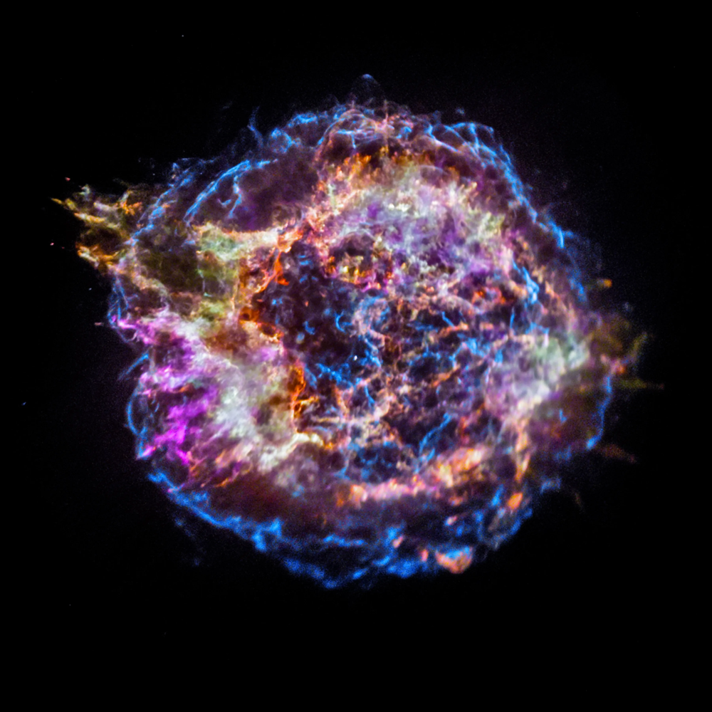
Chandra X-ray image of the Cassiopeia A supernova remnant. Different colors map the presence of elements forged in the explosion – for example, green represents calcium. The outer blue ring is the shock wave from the blast. Astronomers study such remnants to understand how stars produce and disseminate the elements essential for planets and life[4].
Over time (on the order of billions of years), this dispersed calcium became part of new cosmic structures. The cloud of gas and dust that collapsed to form our solar system was enriched by earlier supernova remnants. Thus, when Earth formed around 4.5 billion years ago, it already contained calcium and other heavy elements that originated in stellar furnaces. In that sense, the calcium in a child’s bones is literally older than the Earth itself, having been forged in ancient stars and then delivered here through the natural chain of cosmic events[5]. From a theistic perspective, this astonishing sequence is far from a mere accident – it can be seen as part of a providential plan. The Creator fashioned a universe in which stellar alchemy would generate the very materials needed for life. As the Quran reminds believers, “He forged the sun and lit it” (to paraphrase), and one might add that within those stellar fires God prepared the elements that would one day build living bodies. Indeed, “every single atom in your body—the calcium in your bones…—was created in a star billions of years ago”[5]. For people of faith, such scientific insights deepen our awe of the Almighty’s creative wisdom in designing a life-friendly cosmos.

From Stardust to Earth: Calcium’s Delivery and Life’s Evolution
Having arrived on Earth as part of the planet’s primordial makeup, calcium did not remain inert in rocks – it became a key player in life’s story. Early oceans carried dissolved calcium ions, and as life evolved in those seas, organisms learned to use calcium to build hard parts. In fact, the emergence of skeletons in Earth’s organisms is closely tied to the availability of calcium in the environment. Paleontologists have found that many animal groups independently evolved mineralized shells or skeletons during the Cambrian period (over 500 million years ago), often using calcium compounds[6]. This proliferation of hard-bodied creatures in the fossil record – sometimes called the “Cambrian explosion” – might have been enabled by a surplus of calcium in seawater. One scientific theory even suggests that early animals began forming calcium-based skeletons partly as a way to safely dispose of excess calcium in their cells and environment[7]. Whether by necessity or opportunity, life’s blueprint ingeniously incorporated this abundant element into its structure.
Calcium-based structures took many forms in evolving life. Marine organisms like corals, mollusks, and some algae built protective shells or exoskeletons of calcium carbonate (the compound in chalk and limestone). Meanwhile, our own distant ancestors – the early vertebrates – pioneered the use of calcium phosphate in building internal skeletons. The first fish with bony skeletons had arisen by the late Silurian period, their bones composed of the calcium-phosphate mineral hydroxyapatite. This was a momentous innovation: sturdy bones allowed vertebrates to grow in size and eventually venture onto land, their skeletons strong enough to support weight under gravity. Bone tissue is a remarkable biological composite, combining resilient organic collagen with hard calcium mineral. The basic molecular tools for mineralizing tissue are so ancient and universal that even distantly related organisms can recognize each other’s bone-making chemistry[8]. For example, the proteins that an oyster uses to build its shell can, in the lab, stimulate bone growth in a vertebrate[8]. To believers, such elegant convergence in nature reflects a unifying Providence – a single Designer behind the diverse forms of life, endowing them with the capacity to make use of the materials He provided.
From a theological viewpoint, the evolutionary adoption of calcium for skeletons can be seen as part of God’s plan to enable complex, durable life. The Quran often invites humankind to reflect on the signs in creation; one might consider the widespread appearance of calcium-based bones and shells as one such sign. The potential of calcium was “written into” the fabric of creation (via cosmic processes) well before life appeared, and when life did appear, it was able to utilize that gift. This synergy between the environment and biology resonates with the idea of Tawḥīd (divine unity in Islam) – that all aspects of nature work in concert under God’s will. In the words of the Bible (another theistic source), “the heavens declare the glory of God; the skies proclaim the work of His hands” – and we might add that even the calcium in our bones declares that glory, having traveled across eons to become part of us. Such reflections underscore a general theistic theme: evolution and natural history are not accidents, but instruments of divine providence.

Calcium in Bones: The Foundation of Strength
When we consider why calcium is so important for our bodies, we need look no further than our skeleton. Calcium is the most abundant mineral in the human body, and nearly all of it is stored in our bones and teeth. In fact, about 99% of the calcium in the body is found in bones and teeth, primarily in the form of calcium phosphate crystals (hydroxyapatite) that give hard structure to these tissues[9]. This mineral component is what makes bones rigid, strong, and capable of supporting our weight. Without calcium, our bones would be soft like rubber; it is calcium compounds that harden the collagen framework of bone, enabling our skeleton to protect organs and anchor muscles. Teeth likewise owe their hardness to calcium salts.
The role of calcium in the skeleton is so critical that our bodies have a regulated system to maintain calcium levels. If dietary calcium is insufficient, the body will actually withdraw calcium from bones (weakening them) to keep blood calcium levels stable for other vital functions. This speaks to calcium’s importance beyond just structure: the ~1% of calcium not in our bones resides in blood and soft tissues[9], where it is essential for muscle contractions, nerve signaling, and blood clotting. Thus, calcium is truly a cornerstone of both our anatomy (as the key to bone strength) and our physiology (as a trigger for biological processes). One cannot help but marvel at how a substance forged in ancient stars now courses through our bloodstream and forms the very scaffold of our bodies – a reminder, perhaps, of the mysterious connection between us and the cosmos. From a faith perspective, this intricate dependency can be viewed as part of God’s providential care: the Creator not only provided calcium through cosmic events, but also endowed living organisms with the mechanisms to use it for their benefit. Our sturdy bones are a daily, living testament to that provision – “for you in bones is a sign,” one might say, echoing the Quranic style of pointing to natural phenomena as signs (āyāt) of the Divine.

Nutritional Pathways: Milk and Dietary Calcium
Since our bodies cannot create calcium out of nothing, we rely on dietary sources to replenish this mineral. Here again we find a chain of provision in nature. Plants absorb calcium from the soil; herbivorous animals eat those plants and incorporate calcium into their bodies (meat, milk, bones); and humans obtain calcium by consuming both plants and animal products. Many foods provide calcium, but some of the richest and most bioavailable sources are:
- Dairy products: Milk, cheese, and yogurt are famous for their high calcium content. Just one glass of milk (about 237 ml) contains roughly 300 milligrams of calcium[10] – a substantial fraction of the daily requirement. Dairy calcium is readily absorbed, especially when paired with vitamin D (often added to milk as fortification).
- Leafy greens: Vegetables like kale, broccoli, and spinach contain calcium (though absorption from some greens can be lower due to other compounds).
- Seafood and bones: Canned fish with edible bones (e.g. sardines, salmon) provide calcium, as do bone broths.
- Nuts, seeds, and legumes: Almonds, sesame seeds (and tahini), beans, and tofu (if set with calcium salts) can contribute calcium in diets, particularly important in non-dairy diets.
Notably, milk stands out as a nearly complete nutritional package that many cultures have relied on for bone health. From a theological perspective, milk is often highlighted as a special blessing. In the Islamic tradition, the Quran explicitly draws attention to the miracle of milk production in cattle: “And indeed, for you in grazing livestock is a lesson. We give you drink from what is in their bellies – between excretion and blood – pure milk, palatable to drinkers.”[11]. This verse marvels at how a cow’s body, by God’s design, produces wholesome milk from the grass it eats – a substance that emerges pure and nourishing, despite being synthesized between blood and digested food. For believers, this is a clear sign of Divine providence: God is providing sustenance to mankind (calcium-rich milk) through the biology of humble animals. It is striking that modern science, in decoding the biology of lactation, echoes this wonder – milk is indeed filtered and secreted from blood plasma, containing nutrients (like calcium, proteins, fats) drawn from the mother’s diet and body stores, yet free of impurities.
Another profound provision is mother’s milk for human infants. Human breast milk not only contains calcium for building the baby’s growing bones, but it also delivers it in a perfect form and amount that the infant can absorb. In fact, breastfed infants typically have excellent calcium nutrition for bone development, even though breast milk is not extremely high in calcium – its bioavailability is high and it is coupled with other factors ideal for the baby. The Quran encourages mothers to nurse their babies for two full years, which aligns with modern recommendations for infant nutrition and bonding. As the Quran states: “Mothers may breastfeed their children two complete years for whoever wishes to complete the nursing [period]…”[12]. This guidance, given over fourteen centuries ago, reflects a wisdom that many Muslims see as divinely inspired. Breast milk is a newborn’s first source of calcium (and nearly everything else), and nursing for up to two years helps ensure strong early growth. Contemporary science supports the multitude of benefits of prolonged breastfeeding – from immune protection to proper skeletal development – highlighting a convergence between revelation and reason. A hadith (saying of Prophet Muhammad) even notes that “no baby has ever suckled milk better for him than his mother’s milk”, emphasizing the providential quality of this natural provision.
In considering our diet, we see that God’s providence operates through natural systems: the soil has the mineral, plants take it up, animals concentrate it, and we obtain it in palatable forms. Milk from cows or goats is one especially convenient avenue, almost as if creation was “tailored” to our needs. Indeed, in Islamic thought, one of God’s names is Ar-Razzāq, meaning “The Provider.” The wholesome foods rich in calcium can be viewed as manifestations of that name – gifts placed within creation to sustain us. When we drink a glass of milk or enjoy cheese and green vegetables, from a faith perspective we are not merely consuming impersonal matter; we are partaking in a deliberate network of blessing that originates with the Creator. As another scriptural verse says, “(God) brought forth for you crops... and the fruits of palm and grapes… Surely in that is a sign for people who reflect.” In the same spirit, we can say: He brought forth for us calcium in the stars and delivered it through cows and mothers – signs for those who reflect on God’s care.

Epilogue: A Tapestry of Providence in Cosmology, Evolution, and Biology
The journey of calcium – from star to soil to skeleton – is a grand tapestry that bridges the cosmic and the intimate. On the grand scale, the nuclear reactions in stars and the explosions of supernovae were the first chapter, seeding the universe with life’s raw ingredients. On the earthly scale, geological and evolutionary processes took up the thread, weaving calcium into living forms through shells and backbones. Finally, on the personal scale, biological and social systems ensure that each new generation receives calcium – whether through a mother’s milk or the food we cultivate and domesticate. What is truly remarkable is how seamlessly these chapters connect. The calcium that blazes in a supernova remnant as a green glow on an X-ray image[4] is the same calcium that quietly strengthens the bones of a child drinking milk. To a secular mind, this might be a beautiful coincidence – a natural outcome of physical laws and natural selection. But to a theistic mind (be it Muslim, Christian, or otherwise), there is something more intentional at work: an intricate Providence that has operated over billions of years to prepare a world where humans (and countless other creatures) can thrive.
In Islamic theology, the concept of Qadar (divine planning or destiny) suggests that God has ordained the measure of all things. One might poetically say that God destined calcium to be the bone of our bones. Long before any human walked the Earth, the Creator was, through the laws of physics He set, forging calcium in stars and arranging for its delivery into the crust of a blue planet. Such reflections inspire humility and gratitude. The Prophet Muhammad (peace be upon him) taught that even a morsel of food we eat should evoke thankfulness to God – how about the very structure of our bodies? Every time we stand upright on strong legs or bite into an apple with sturdy teeth, we are beneficiaries of a cosmic-alchemical gift. The Psalmist in the Bible sang, “I praise You, for I am fearfully and wonderfully made.” In the same vein, a Muslim might exclaim “Subḥān Allāh” (Glory be to God) when studying the elegance of how our bodies are constructed from stardust.
Ultimately, the story of calcium unites scientific insight with spiritual insight. It shows that religious wonder and scientific wonder are not opposed but can complement each other. Science tells us how calcium came to be and how it works in our bodies; faith ponders why such a life-enabling coherence exists at all. The general theist perspective sees purpose: it sees a generous God stitching together the fabric of reality in such a way that our needs are met, often in ways we did not even imagine until science revealed them. The special emphasis of Islam adds specific texture to this tapestry, with verses that encourage us to ponder the miracles in cattle’s milk and mother’s milk, and by extension, all the processes that sustain life. In conclusion, the existence and journey of calcium – from the fusion in distant stars to the nourishment in a glass of milk – can be viewed as a testament to God’s providence and wisdom. It invites us to marvel at the natural world, to deepen our scientific curiosity, and simultaneously to feel a deeper reverence for the Creator who “has subjected to you whatever is in the heavens and whatever is on the earth, all from Him” (Quran 45:13). In calcium’s saga, we find a theme that resonates across cosmology, evolution, and biology: a theme of provision, connectivity, and purposeful design – truly an amazing providence for us.
Sources: The NASA Imagine the Universe program (Goddard Space Flight Center) provides educational insight into the stellar origin of calcium[1]. Recent astrophysical studies (e.g., Vice News reporting on 2020 findings) have confirmed that calcium in our bones was forged in supernovae[2]. The PBS NOVA science series eloquently summarizes our stardust origins[5]. In the realm of biology, data from the Linus Pauling Institute and other sources detail the dominance of calcium in bone composition[9]. Paleontological research illustrates how early life forms adopted calcium-based skeletons during the Cambrian explosion[7]. Dietary facts are supported by educational materials linking cosmic calcium to milk calcium[10]. Theological references include direct Quranic verses about cattle milk[11] and breastfeeding[12], reflecting the Islamic view of nourishment as a sign of God’s care. Together, these sources weave a narrative that is at once scientific and spiritual, helping us appreciate the full scope of calcium’s remarkable journey.

[1] [3] [10] Got Calcium?
https://imagine.gsfc.nasa.gov/educators/calcium/got_calcium_litho.html
[2] Exploding Stars Created the Calcium in Our Bodies, Says Study
https://www.vice.com/en/article/exploding-stars-supernova-created-calcium-says-study/
[4] Chandra Reveals the Elementary Nature of Cassiopeia A - NASA Science
https://science.nasa.gov/image-detail/where-do-most-of-the-elements-essential-for-life-on-earth-come-from-the-answer-inside-the-furnaces-of-stars-and-the-explosions-that-mark-the-end-of-some-stars-lives-3/
[5] The Star In You | NOVA | PBS
https://www.pbs.org/wgbh/nova/article/star-in-you/
[6] [7] [8] Patterns in Palaeontology — The earliest skeletons – PALAEONTOLOGY[online]
https://www.palaeontologyonline.com/?p=4722
[9] Bone Health In Depth | Linus Pauling Institute | Oregon State University
https://lpi.oregonstate.edu/mic/health-disease/bone-health
[11] The Quranic Arabic Corpus - Translation
https://corpus.quran.com/translation.jsp?chapter=16&verse=66
[12] Wisdom Behind Two Years of Breastfeeding - A Scientific Perspective
https://www.islamweb.net/en/article/236410/wisdom-behind-two-years-of-breastfeeding-a-scientific-perspective

