History of the Jamarat Ritual (Stoning of the Devil) in Mecca
Presented by Zia H Shah MD

Early Islamic Origins and Significance
The ritual of ramī al-jamarāt (“stoning of the pillars”) dates back to the dawn of Islam and is rooted in the story of Prophet Ibrahim (Abraham) and his steadfastness against Satan[1][2]. According to Islamic tradition, when Ibrahim was commanded by Allah to sacrifice his son (Ismail), the devil attempted to dissuade him at three separate locations in Mina. Each time, the Angel Jibril (Gabriel) instructed Ibrahim to pelt the devil with seven pebbles, causing Satan to flee[3]. This act of defiance was later incorporated by the Prophet Muhammad into the Hajj rites, to commemorate Ibrahim’s obedience and the rejection of evil[1][2]. In his Farewell Hajj (632 CE), Prophet Muhammad personally performed the stoning at the Jamarat, throwing seven pebbles at each pillar while pronouncing “Allāhu Akbar” (God is greatest)[4][5]. These actions of the Prophet – documented in authentic hadith collections – established the Jamarat stoning as an obligatory ritual of Hajj[6]. There is no direct verse in the Qur’an about stoning Jamarat; its authority comes from the Sunnah (Prophetic practice) and consensus of scholars[6][7]. The ritual symbolizes the pilgrim’s rejection of temptation and steadfast obedience to Allah, emulating Ibrahim’s rejection of Satan[8][9]. Islamic scholars like al-Ghazali emphasize that the underlying purpose is submission to God’s command, reenacting Ibrahim’s act without question, and “throwing” one’s own temptations and sins away[8].
Jamarat: Hajj vs. ‘Umrah – When Is It Performed? It is important to note that the stoning of the Jamarat is only performed during the Hajj pilgrimage, not during the lesser ‘Umrah. The three Jamarat (small, medium, and large) are located in Mina and are visited on specific days of Hajj (10th through 13th of Dhu al-Hijjah). In contrast, an ‘Umrah consists of ihram, Tawaf, and Sa’i and does not include traveling to Mina or stoning any pillars[10]. In fact, “stoning the Jamarat is one of the obligatory rituals of Hajj”[6] and without it a Hajj is incomplete[11][12], whereas ‘Umrah pilgrims do not perform this ritual at all.

The Ritual in the Early and Medieval Periods
From the earliest Islamic era through the medieval period (Umayyad, Abbasid, and Mamluk times), the Jamarat ritual remained fundamentally the same as established by the Prophet. Early Muslim communities strictly followed the Prophetic method: after the Day of `Arafāt, pilgrims would gather pebbles in Muzdalifah at night and then perform the stoning in Mina over the next three days[13][14]. Historical accounts by Muslim travelers and historians indicate the continuity of this practice across centuries. For example, the 9th-century Meccan historian Al-Azraqi recorded the Ibrahim narrative and described how pilgrims reenact it during Hajj[1][2]. Likewise, medieval travelers like Ibn Jubayr (12th century) and Ibn Battuta (14th century) mention pilgrims throwing stones at pillars representing Satan in Mina, underscoring that this ritual was an unwavering part of Hajj throughout the Abbasid era and beyond (these accounts affirm the unbroken tradition, although the physical setting was simpler than today). The ritual timing was also standardized early on: pilgrims stone only the largest pillar (Jamrat al-‘Aqaba) on Eid day (10th Dhu al-Hijjah) and all three Jamarat on the 11th, 12th, and (optionally) 13th, following the Sunnah schedule[15][16].
During these early and medieval centuries, the physical form of the Jamarat was very basic. Each Jamrah was reportedly marked by a simple heap of stones or a small pillar as a target. Over time, low walls or ringed enclosures were placed around the pillars to catch the pebbles. By the Abbasid period, the authorities overseeing Hajj ensured the pillars were maintained as clear markers, but there were no elaborate structures. Pilgrim numbers in those eras (ranging from a few thousand to tens of thousands annually) were manageable enough that the stoning ritual, although crowded, did not yet necessitate major infrastructure beyond basic crowd control by soldiers or attendants of the Sharifs of Mecca. The Abbasid caliphs and later Muslim rulers took interest in facilitating Hajj — repairing roads, providing water, etc. — but the act of ramī itself remained a simple, symbolic pelting of small pillars, performed as an act of worship and spiritual significance.

The Ottoman Era (16th–19th Centuries)
When the Ottoman Empire assumed control of the Hijaz (16th century), they became custodians of the holy sites, including the Hajj rituals. Under Ottoman administration, the stoning of the Jamarat continued in its traditional form, though growing pilgrim numbers (especially by the 19th century) made the ritual increasingly congested. The Ottomans maintained the three Jamarat pillars and likely reinforced them periodically. By the late Ottoman period, the pillars were fixed structures of stone (and mud) with low circular walls around each to hold the pebbles[17]. Contemporary descriptions note that the Jamarat pillars resembled stone obelisks, standing a few meters high. Pilgrims would crowd around each pillar in turn to perform the stoning. Photographic evidence from the early 20th century (just after the Ottoman era) shows that the Jamarat sites were open-air and surrounded by minimal infrastructure – essentially just the pillar in the middle of a basin or enclosure[17][18]. There were no platforms or bridges; pilgrims approached on foot through the Mina valley.
Despite the lack of modern facilities, the Ottomans did attempt basic crowd management. Historical reports indicate that soldiers or guides were sometimes stationed to regulate the flow of pilgrims during ramī. However, tragic incidents occasionally occurred. One of the earliest large-scale stampedes on record happened in 1887 (during late Ottoman rule), when an overcrowding incident during the stoning in Mina led to many casualties (sources differ on the exact number, but it was a significant tragedy of that era). Such events were harbingers of the challenges that would intensify in the 20th century as Hajj attendance kept growing. Overall, the Ottoman period served as a bridge between the pre-modern simplicity of the ritual and the need for modernization that became apparent in the 20th century.
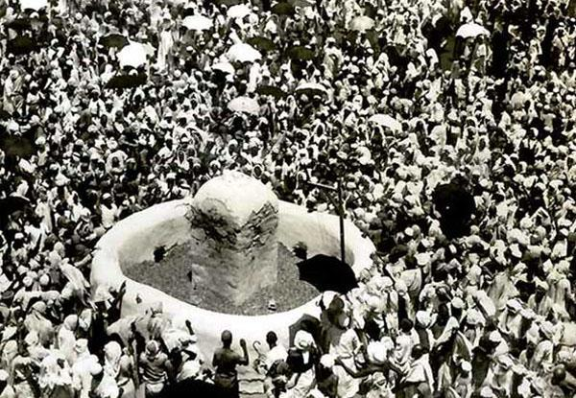
Pilgrims stoning one of the Jamarat pillars in Mina, in a historical photo from 1942. The stoning ritual took place in open grounds with a short circular wall around the pillar, essentially unchanged in form since the late Ottoman era[17].
(Above: The crowded scene around the Jamarat al-‘Aqaba in 1942 illustrates the traditional setup: a stone pillar in a basin, with thousands of pilgrims trying to stone it. This is representative of how the Jamarat looked and functioned through the Ottoman period and up to the mid-20th century.)[19]

Mid-20th Century Modernization (Early Saudi Era)
By the mid-20th century, under the Kingdom of Saudi Arabia, the Hajj began to see dramatic increases in the number of pilgrims (hundreds of thousands annually, compared to tens of thousands in earlier eras). The traditional Jamarat pillars – still relatively small and unchanged in design – became a serious bottleneck and safety hazard during peak pilgrimage days. Through the 1940s and 1950s, the ritual was still performed as it had been for centuries: pilgrims thronged around each pillar to cast their pebbles. Photographs from the 1950s show small stone pillars being pelted by crowds in an increasingly dense sea of people[20].
In response, the Saudi authorities began implementing improvements. Minor modifications (e.g. widening the circular walls around the pillars) were made in the 1950s to slightly increase capacity for stone collecting. A major innovation came in 1963, when the first Jamarat Bridge was constructed[21][22]. This was an elevated pedestrian bridge at Jamrat al-‘Aqaba (the largest and most crowded pillar) that allowed some pilgrims to perform the stoning from atop the platform while others still did so at ground level. The original 1963 bridge was a single deck above ground level[21]. Although modest in scale, this was a pivotal development in Hajj infrastructure, introducing multi-level access to the Jamarat to reduce crowd pressure.
Throughout the 1970s–90s, the Saudi government undertook successive expansions and reinforcements of the Jamarat facilities. In 1974, the Jamarat Bridge was substantially rebuilt and extended to cover all three Jamarat, forming a continuous raised platform through Mina[23]. The redesigned bridge in 1974 had a width of about 40 meters and incorporated ramps for easier entry and exit[23]. Over the next decades, expansions continued: 1982 saw the bridge lengthened to 120 m and widened to 20 m[24], and 1987 expanded it further to 520 m long and 80 m wide[24]. By the late 1980s the Jamarat Bridge spanned a large area with a second level, allowing pilgrims to stone from either level at the same pillars. Even so, the basic design of the shaʿāir (the Jamarat pillars themselves) remained as cylindrical concrete columns in the middle of circular pits, essentially the same targets as before. The size of the pillars had “remained unchanged for years” despite being covered in cement for durability[17]. Pilgrim congestion thus continued to be an issue, as millions now attended Hajj annually.
A mid-20th century view (circa 1953) of the Jamarat in Mina. The three Jamarat were then small stone pillars in open courtyards, symbolizing the spots where Ibrahim stoned the devil[20]. Pilgrims would crowd closely around each pillar to perform the ritual, as seen here, before the construction of multi-level bridges.
(Above: 1950s photograph showing one of the Jamarat pillars up close. Note the low basin and the pillar’s modest height – this traditional design persisted until the early 2000s. Such images highlight why congestion became a problem as Hajj crowds grew.)[20]
Despite incremental improvements, several tragedies during Hajj underscored the need for a complete overhaul of the Jamarat area. Notably, stampedes and crowd crush incidents occurred in 1994, 1998, 2001 and 2003 at or near the Jamarat Bridge, resulting in hundreds of deaths[25][26]. These incidents were often triggered by the sheer press of pilgrims all converging to stone the pillars at similar times. In 1995, in response to these dangers, the bridge was retrofitted with additional safety features (such as improved signage, emergency exits, and better directional flow markings)[27]. Authorities also began staggering group timings and issuing warnings in multiple languages to prevent overcrowding[27]. However, the basic structural constraints remained – the single-tier bridge and small targets created choke points.

Post-2000 Infrastructure Developments
Entering the 21st century, Saudi authorities embarked on a massive redesign of the Jamarat facilities to prioritize safety and accommodate the ever-growing influx of pilgrims. The turning point came after the Hajj stampede of January 2006, one of the deadliest incidents in Hajj history, in which at least 346 pilgrims died during the stoning ritual crush[28][29] (this followed a 2004 stampede that had killed 251 pilgrims[28]). Immediately after the 2004 incident, plans were announced to completely rebuild the Jamarat Bridge and modify the pillars[30]. By the end of 2005, the three old cylindrical pillars were replaced with long, oval-shaped walls of concrete, much taller and wider than before[30]. These new elongated Jamrah monoliths (aligned in the same locations as the old pillars) allowed many more pilgrims to stone simultaneously from all sides, reducing bottlenecks[30]. The circular pebble-catching basins were also widened and made oval in shape to fit the new design[31][32].
Following the 2006 Hajj, the old two-level bridge was completely demolished and construction began on a state-of-the-art Jamarat Complex. The new Jamarat Bridge structure opened in phases between 2006 and 2009[33][34]. As of its completion in 2009, the Jamarat Bridge is a five-story building with each level directly accessing the three Jamrah walls[35][36]. The new bridge is about 950 meters long and 80 meters wide, with foundations engineered to support up to 12 levels in the future[37][38]. It features 11 entrances and 12 exits to channel pilgrims smoothly in and out[39]. There are ramps and escalators, and separate pathways leading to each level from different directions to distribute the crowds. Modern crowd-control technology has been integrated: hundreds of CCTV cameras monitor the flow, and authorities can halt or redirect groups when needed from a central control room[40][41]. The complex even includes helipads for emergency evacuation and a misting climate-control system that sprays cooling mist over the crowds to mitigate the desert heat[42].
One of the most crucial outcomes of the redesign was enhanced safety. The spacious pillars and multiple levels eliminated the intense congestion around a single small spot. Pilgrims can now perform ramī from ground level or any of the four upper stories, greatly increasing throughput. The capacity of the new Jamarat facility is approximately 300,000 pilgrims per hour[43][44], a figure that was impossible in the old design. Indeed, the new bridge won engineering awards for its innovative design in handling human traffic[45][46]. Since the upgrade, the stoning ritual has proceeded with much fewer incidents; although the 2015 Mina stampede (which took place on approaches to Jamarat, not at the pillars themselves) was a stark reminder of ongoing challenges, it led to further refinements in crowd scheduling and route management. By staggering group movements and using technology to prevent overcrowding, Saudi authorities report that “overcrowding and discomfort are a thing of the past” at the Jamarat Bridge[46][47].
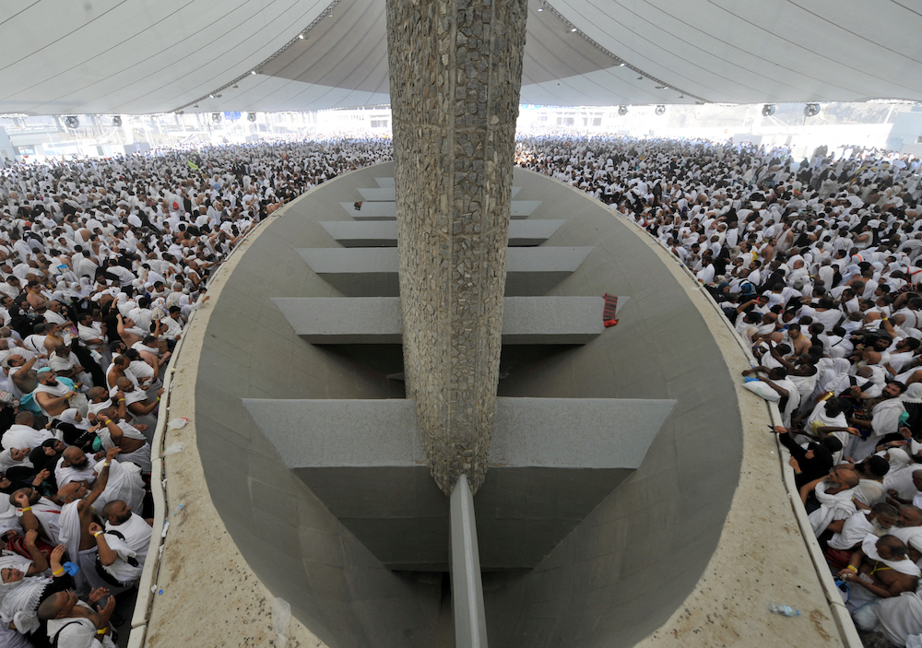
The modern Jamarat: Pilgrims at one of the new elongated Jamarat walls under the canopy (recent years). The post-2006 design replaced the old narrow pillars with broad oval walls, vastly improving crowd flow and safety[30]. Multiple tiers of the Jamarat Bridge allow stoning from different levels simultaneously.
(Above: Interior view of the Jamarat area on an upper level – the stone-faced wall (Jamrah) runs through the center, surrounded by a large elliptical basin to catch pebbles. Canopies overhead shield pilgrims from the sun. This design was implemented in 2006–2009 and reflects the extensive modernization of Hajj infrastructure.)[30]

Conclusion
Over the past 1500 years, the Jamarat ritual in Mecca has evolved from a simple reenactment performed by a modest number of pilgrims into a massive operation involving millions of people and sophisticated engineering. In the early Islamic and medieval eras, the act of stoning the Jamarat remained spiritually central to Hajj, unchanged in method and meaning, passed down exactly as the Prophet Muhammad performed it in emulation of Prophet Ibrahim. In the Ottoman period, as the custodian of the Hajj, the Muslim world saw continuity in the ritual’s practice, albeit with the first signs of crowd management challenges. The 20th century – especially under Saudi administration – brought the first concerted efforts to modernize the Jamarat area (the introduction of bridges, widened pillars, and safety measures) in response to increasing pilgrim numbers and tragic incidents. Finally, the 21st-century upgrades transformed the Jamarat into a multi-level, high-capacity complex, making the ritual safer and smoother than ever before. Through all these physical changes, the theological essence of the Jamarat ritual remains intact: it is a symbolic casting away of evil and an affirmation of obedience to God. The sight of pilgrims hurling pebbles at the Jamarat – whether in 7th-century open fields or on a 5-story bridge with misting fans – powerfully connects today’s believers with a tradition and history stretching back to Prophet Ibrahim almost 4000 years ago, and it continues to be one of the most significant and dramatic rites of the Hajj.
Sources: Historical and religious information has been drawn from reputable Islamic scholarly sources, including hadith collections and classical historians[1][4], as well as academic and official reports on Hajj infrastructure developments[23][27]. Data on modern changes and safety improvements are based on official Saudi Hajj authorities’ publications and news reports (Arab News, Reuters) detailing the Jamarat Bridge expansion and upgrades[47][30]. All images are used to illustrate the Jamarat area’s evolution over time, with appropriate credit to their original sources.

[1] [2] [3] [9] [13] [14] [15] The story behind the stoning of Satan during Hajj| IslamicFinder
https://www.islamicfinder.org/news/the-story-behind-the-stoning-of-satan-during-hajj/
[4] [5] [6] [7] [8] Is Stoning the Jamarat Part of Hajj? - Islam Question & Answer
https://islamqa.info/en/answers/125711
[10] Understanding the Difference Between Hajj and Umrah
https://zamzamtravelsbd.com/difference-between-hajj-and-umrah
[11] [12] [17] [18] [22] [45] [46] [47] How award-winning Jamarat Bridge provides relief to pilgrims during key Hajj ritual | Arab News
https://www.arabnews.com/node/2119591/saudi-arabia
[16] What is Jamarat? The Three Stone Pillars | About Islam
https://aboutislam.net/reading-islam/understanding-islam/jamarat-three-stone-pillars/
[19] [31] [32] [37] [38] [39] [40] [41] [42] جسر الجمرات - ويكيبيديا
https://ar.wikipedia.org/wiki/%D8%AC%D8%B3%D8%B1_%D8%A7%D9%84%D8%AC%D9%85%D8%B1%D8%A7%D8%AA
[20] 25 Amazing Photos from Hajj 1953 - IlmFeed
https://ilmfeed.com/25-amazing-photos-hajj-1953/
[21] [25] [26] [28] [29] [30] [33] [34] Jamaraat Bridge - Wikipedia
https://en.wikipedia.org/wiki/Jamaraat_Bridge
[23] [24] [27] [35] [36] [43] [44] Jamarat Complex - Saudipedia
https://saudipedia.com/en/article/455/religion/hajj-and-umrah/jamarat-complex

