Guided Evolution: Harmony of Divine Purpose and Natural Process
Written and collected by Zia H Shah MD

Abstract
In a world of breathtaking biological diversity, guided evolution offers a perspective that marries scientific understanding with spiritual insight. Rather than seeing evolution as a blind, random process, this view proposes that evolution is the method by which a wise Creator unfolds life’s tapestry – gradually, majestically, and with purpose. By examining the Quran’s own references to nature’s order and beauty, we find a consonance between faith and science. The metamorphosis of a humble caterpillar into a radiant butterfly and the peacock’s extravagant plumage are two striking examples: both illustrate complexity and beauty that hint at intentional design rather than mere chance. Drawing on the works of Zia H. Shah MD and Quranic verses, this article argues that nature’s wonders – from a butterfly’s chrysalis to the “eyes” on a peacock’s tail – reflect a divinely guided evolutionary process. In Islam, God’s creative agency and the observable mechanisms of evolution are not at odds. Instead, they form a harmonious narrative in which nature is a revelation: a living scripture that, alongside the written Quran, guides us to the truth that behind life’s evolution is an intelligent, benevolent purpose.

Quranic Perspective on Guided Evolution
The Qur’an portrays creation as a deliberate, ordered process under divine guidance. It emphatically states that God “perfected everything which He created” (Qur’an 32:7)[1]. Rather than a haphazard outcome, every creature is formed in a fitting manner, reflecting intention and wisdom. In Islamic thought, one of the names of God is Al-Muṣawwir – “The Fashioner” or Bestower of Forms (Qur’an 59:24), indicating that the diversity of forms in nature is the result of a conscious artistry[1]. Another divine name, Ar-Rabb (often translated “Lord”), carries the meaning of a nurturer who guides things through stages to their completion. As one commentary highlights, Ar-Rabb encapsulates God’s nurturing guidance, “progressively from one stage to the next until it reaches its goal of perfection”[2]. In essence, the concept of guided evolution is the idea that evolution is how Allah creates – not aimlessly, but with gradual unfolding and direction towards purposeful ends[3][2].
Crucially, the Quran invites us to observe patterns and origins in the natural world as signs of this guided process. “Travel through the earth and observe how He began creation,” it encourages (Qur’an 29:20), underscoring that the story of life’s development holds divine lessons. The Quran describes life emerging from water (Qur’an 21:30, 24:45) and humanity’s own physical creation as originating from earth’s elements (clay), then developing through mingled fluids and embryonic stages[3]. “He began the creation of man from clay. Then made his progeny from a humble fluid…” — these words in Qur’an 32:7–8 are followed by, “Then He proportioned him and breathed into him of His Spirit…” (32:9). According to Zia H. Shah MD, this sequence “encapsulates the entire evolutionary process”, with human physical form evolving over time and the divinely given soul marking the culmination of humanity’s creation[3]. In other words, the Qur’an itself outlines a progression: from simple matter to complex life to conscious humanity – a progression that mirrors what science tells us, but crucially, the Qur’an attributes it to God’s plan and guidance at every step.
[4]The Qur’an also teaches that God endows each creature with its form and then guides it to its destined capabilities (Qur’an 20:50). Classical Islamic scholars interpret this to mean every species is guided to fulfill the purpose intended for it. Modern Muslim thinkers like Zia H. Shah MD see in this a resonance with evolution: just as an embryo is guided to develop into a fully formed human, so too have species been guided through natural laws to their current forms. This guidance operates through what science calls the laws of biology – genetics, natural selection, ecological interactions – but from a faithful perspective, these laws are “divinely guided” instruments of God's creative will[5]. Crucially, such guidance often results in outcomes that “transcend what blind chance alone might achieve”[4]. In simple terms, while evolution involves random mutations and survival pressures, the overall direction and the emergence of remarkable complexity and beauty are seen as signs of a higher orchestration. The Quranic worldview negates the idea that life is an accident; instead, it portrays nature as an expression of qudra (divine power) and hikmah (divine wisdom) working through gradual processes.

The Butterfly: Metamorphosis as a Sign of Guidance
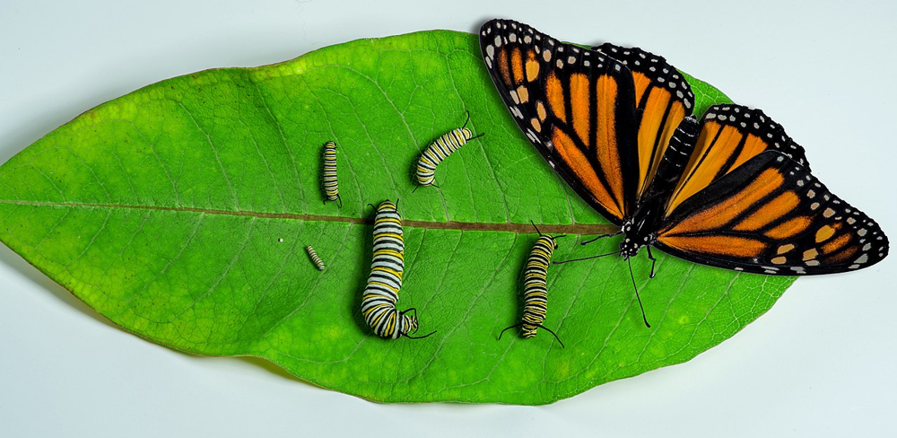
A monarch butterfly alongside its caterpillar stages, symbolizing guided transformation.
One of the most captivating illustrations of nature’s ingenuity is the butterfly’s metamorphosis. Consider how a caterpillar – essentially a crawling tube of appetite – enters a self-made chrysalis, dissolves into an organic soup, and then reassembles into a winged jewel. The transformation is so radical that, as one science writer observed, “it’s hard to believe they belong to the same species”[6]. Inside the chrysalis, a mysterious instruction unfolds: cells are repurposed, new organs formed, wings painted with vibrant colors. If one did not know better, it would appear almost miraculous – a kind of resurrection in miniature. Indeed, researchers have found that despite the caterpillar’s body disintegrating, certain memories can carry over into the butterfly, implying an astonishing continuity amid change[7][8]. This complex process is encoded in the insect’s DNA – a biological program fine-tuned over eons, yet to the faithful eye, it signals an Architect who wrote the program.
In Islamic reflection, such ayat (signs) in nature are tangible lessons. Zia H. Shah MD points out that when we marvel at “the metamorphosis of a caterpillar into a butterfly with dazzling wings,” we are “stepping onto a path of wonder that can lead to God.”[9] Rather than seeing the butterfly’s life cycle as a quirk of evolution, he invites us to view it as a guided journey – a lowly larva guided to become a creature of air and light. The Qur’an draws a parallel in human development: “You were created in stages” (Qur’an 71:14) and “Allah has caused you to grow from the earth a progressive growth” (Qur’an 71:17). Just as a butterfly’s stages (egg, caterpillar, pupa, adult) serve a purpose – for example, the crawling caterpillar and winged butterfly occupy different niches, avoiding competition and thus thriving – our own existence has purpose at every stage, guided by the hand that “shaped us and perfected our shapes” (Qur’an 40:64)[10]. The scientific explanation for metamorphosis highlights survival advantages (the larval stage focusing on growth, the adult on reproduction and dispersal)[11]. But why such an extraordinary strategy exists at all sparks reflection beyond science. To believers, the butterfly’s story is like a living parable: transformation and renewal are built into life by design. The caterpillar’s seemingly mundane existence was always intended to culminate in the airborne elegance of the butterfly – just as, one might say, the saga of evolution harbored the eventual emergence of conscious, worshipful beings. In the Quranic view, the same God who guides the butterfly out of its cocoon has guided life through its myriad transitions: “Our Lord is He who gave everything its form and then guided it” (20:50). Metamorphosis thus testifies to a creation that is not only dynamic and developmental, but intentionally so – an evolution with divine direction.

The Peacock’s Tail: Beauty Beyond Survival
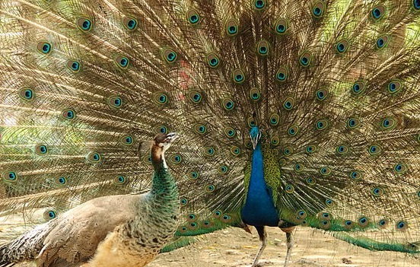
A peacock displaying its ornate tail feathers to a peahen – a classic puzzle of evolution.
If the butterfly represents transformation, the peacock exemplifies nature’s extravagant beauty. The male peacock’s tail, with its iridescent fan of indigo, green, and gold “eyes,” is arguably one of the most beautiful structures in the animal kingdom. Yet, its very beauty poses a question: How did such an ostensibly impractical feature evolve? The tail is heavy and conspicuous – not exactly ideal for escaping predators. Charles Darwin himself was initially perplexed. In a famous 1860 letter, Darwin admitted that “the sight of a feather in a peacock’s tail, whenever I gaze at it, makes me sick!” – it troubled him because it seemed excessive for mere survival advantage[12]. Ultimately, Darwin proposed sexual selection as the answer: across generations, peahens chose the most beautiful males, driving the evolution of ever more resplendent tails. This explanation still stands in evolutionary biology. However, the deeper mystery of beauty remains a point of reflection. Why is the peahen enthralled by those mesmerizing eyespots to begin with? Why does beauty seem to hold such sway in nature? From a materialist view, one might shrug and say it’s an arbitrary preference that happened to spread. But to a theist, the peacock’s tail is a vivid signature of a Creator who loves beauty and has woven it into the very fabric of life.
Zia H. Shah MD notes that the peacock’s plumage has long been held up as an example of aesthetic design in nature[13]. Its beauty delights observers yet transcends utilitarian need. Yes, it serves to attract mates – but it also attracts our gaze and admiration, hinting that something more than survival is at play. The Qur’an teaches that God is Al-Jamīl, The Beautiful, and loves beauty; it also declares, “He has made everything in the best form” (Qur’an 32:7) and “[Allah] has given you shape and made your shapes beautiful” (Qur’an 40:64)[10]. Thus, from an Islamic perspective, the splendor of the peacock isn’t an evolutionary accident, but rather a deliberate flourish of divine artistry. In Shah’s words, the lavish beauty found in living things reflects Allah’s own attribute of beauty – creation is like a mirror held up to the Creator[14]. Even classical commentators, centuries before Darwin, remarked that every creature has been given an appropriate beauty and symmetry for its role[15]. What may seem “unnecessary” ornamentation to us is, in this view, an expression of God’s limitless creativity.
Modern science has, interestingly, been reexamining the role of beauty in evolution. Some biologists argue that certain features (like elaborate bird songs or vibrant plumage) are driven by aesthetic choices – essentially, creatures appreciating beauty in each other – not just by brute survival calculus. This aligns intriguingly with the Quranic idea that God “fashioned” creatures, endowing them not only with physical forms but with instincts and even preferences that lead to beauty proliferating in the world. The peacock’s tail, then, can be seen as a divinely guided outcome of evolution’s toolkit: natural selection provided the mechanism, but a divine love of beauty set the overarching principle. As Shah emphasizes, the existence of such natural beauty challenges the notion of a purely unguided process. It suggests instead that evolution has a telos – a directed aim – towards dazzling variety, complexity, and beauty, consistent with a Creator who declares, “This is the Work of Allah, who has perfected all things” (cf. Qur’an 27:88). In the end, when a peacock fans out its magnificent tail, we are witnessing more than a mating display; we are witnessing a hint of the sublime purpose imbued in nature.

Epilogue: Nature and Revelation in Harmony
In the butterfly’s emergence from its cocoon and the peacock’s regal display, we find a common theme: nature’s narrative is one of purpose and meaning. Rather than contradicting faith, scientific insights into these phenomena can deepen our appreciation of the divine. The concept of guided evolution posits that accepting evolution does not mean rejecting God – instead, it means marveling at how God works through natural processes. It is a perspective that bridges the perceived gap between science and religion, showing them as allies in truth-seeking. As the Qur’an so beautifully states, “We shall show them Our signs in the horizons and in themselves until it becomes clear to them that He is the Truth” (Qur’an 41:53). Each new discovery in biology or cosmology is, to a believer, yet another sign (āyah) of what the Quran has been saying all along: creation has an Author, and His signatures are everywhere.
Zia H. Shah MD and like-minded scholars invite us to read the “Book of Nature” alongside the revealed Book[16]. In doing so, our understanding of evolution transforms from a cold, random saga into what one might call “the grand divine show on Earth”. Evolution becomes a majestic story scripted by God – one that unfolds over eons, crafting butterflies from caterpillars, and painting forests with birds like the peacock. The harmony between science and faith emerges when we realize they are looking at the same reality from different angles: science explains the mechanisms, faith reveals the meaning. The natural world, with all its beauty and complexity, thus ceases to be an accidental backdrop and is appreciated as an intelligent work of art.
In the end, guided evolution is a profoundly hopeful message. It tells the general public – whether scientifically literate, spiritually inclined, or both – that we do not have to choose between God and evolution. We can embrace the age of the universe, the change of species, and the genetic kinship of life, and see in them the unfolding of divine will. The butterfly and the peacock testify to a truth that resonates in both the laboratory and the mosque: there is an underlying order and direction to existence. This direction, Muslims believe, comes from Allah, “Lord of all the worlds.” The Qur’an’s vision of nature and modern evolutionary science together compose a symphony – one in which every living thing is an instrument playing a part written by the Greatest Composer. In that harmonious view, nature and revelation sing in unison, and those with open hearts can hear in it the echo of God’s guidance, beckoning us to wonder, knowledge, and faith.
✽ “Who is it that created and proportioned, Who destined and then guided?” asks the Qur’an (87:2–3). Reflecting on the butterfly’s metamorphosis and the peacock’s splendor, one cannot help but answer: it is the One who made a world where science and spirituality converge – the One who guides evolution and our understanding of it, every step of the way.
Sources: Zia H. Shah MD – The Quran and Science (thequran.love)[3][2]; The Muslim Times (April 11, 2025)[1][4][12][9]; Wired Science[17][7].

[1] [4] [9] [10] [12] [13] [14] [15] [16] Beauty in Nature as a Path to God: An Islamic Perspective – The Muslim Times
https://themuslimtimes.info/2025/04/11/beauty-in-nature-as-a-path-to-god-an-islamic-perspective/
[2] [3] iicoman.com
https://iicoman.com/uploadsall/Books/7f1de69e-e0ce-48d6-8ea8-e79c7aab94b1.pdf
[5] [PDF] Guided Evolution in Qur'anic Perspective
https://thequran.love/wp-content/uploads/2025/07/guided-evolution-in-quranic-perspective_-a-commentary-on-surah-nue1b8a5.pdf
[6] [7] [8] [17] Butterflies Remember What They Learned as Caterpillars | WIRED
https://www.wired.com/2008/03/butterflies-rem/
[11] How a caterpillar becomes a butterfly: Metamorphosis, explained
https://www.nationalgeographic.com/animals/article/science-of-metamorphosis-butterflies-caterpillars

