The Genetic Ties That Bind: Molecular Evidence of Life’s Common Ancestry
Written and collected by Zia H Shah MD

Abstract
All living organisms, from simple microbes to humans, share a profound family connection written in their molecules. Modern molecular biology has revealed that the DNA code of life is virtually universal, and many organisms carry the same biological building blocks. By comparing genetic sequences, scientists have found striking similarities that point to a common ancestor for all life[1]. In particular, the genomes of humans and our close primate relatives, like chimpanzees, are nearly 99% identical[2]. These genetic parallels extend beyond DNA to the very proteins that build our bodies – many critical proteins are conserved or even identical across species, a clue that they were inherited from shared ancestors rather than invented from scratch[3]. From the fused chromosome in our genome that reveals our ape heritage[4] to ancient viral DNA “fossils” embedded in matching locations of different species’ genomes[5], the evidence for evolution and common descent is written in our cells. This article narrates how DNA, RNA, proteins, and genomic quirks all testify to the unity of life. In accessible language and illustrative diagrams, we explore how molecular biology not only confirms the theory of evolution but also deepens our appreciation of the interconnected story of all life on Earth.

The Universal Code of Life: DNA Links All Living Things
Walk into any biology lab, and you’ll find the same molecular “alphabet” being used to spell out life’s instructions, whether the sample on the slide is bacteria, oak tree, or human. Deoxyribonucleic acid (DNA) – the famous double helix – is the hereditary material for virtually all organisms, and it’s composed of the same four chemical bases (A, T, C, and G) in every species. There’s no separate DNA for dogs and a different DNA for daisies; life’s blueprint is written in a common language. Even viruses (which many scientists don’t classify as fully living) use DNA or a close cousin, RNA, to store genetic information[6]. Moreover, the genetic code itself is nearly universal. This code is like a dictionary translating DNA sequences into proteins, and almost every creature on Earth uses the same dictionary – for example, the DNA sequence “ATG” encodes the amino acid methionine in you, a mushroom, or a blue whale[1]. This shared genetic code is a powerful hint of common ancestry. If life had multiple separate origins, we might expect different codes or entirely different molecular systems in different lineages. Instead, the fact that a human gene can be read and used by a bacterium (scientists routinely insert human genes into bacteria to produce medicines like insulin) shows that our cellular machinery is fundamentally compatible[6]. In all cells, DNA is transcribed into RNA and then translated into proteins by complex molecular machines called ribosomes – and these processes are conserved across all forms of life[7]. Every cell also uses the same energy currency, ATP, to power its reactions[8]. Such universal biochemistry is best explained by inheritance from a common ancestor that established these molecular rules eons ago.
Life’s common molecular language enables some remarkable cross-species substitutions. For instance, researchers have found that the gene for cytochrome c, a vital protein used in cellular respiration, can be swapped between incredibly diverse organisms. Human cytochrome c protein works in yeast cells (a single-celled fungus) that have had their own cytochrome c gene removed[9]. In fact, cytochrome c from fish, birds, mammals, or insects can all function in yeast[10]. This interchangeability underscores that the core machinery of life has been conserved over billions of years. It’s as if very different organisms are using the same spare part, inherited from a distant common toolkit. These shared fundamentals – DNA structure, a universal genetic code, common metabolic pathways – set the stage for the more detailed evidence of evolution. With the molecular language in common, scientists can directly compare genetic messages between species to deduce their relationships. And when we turn to those comparisons, the family tree of life comes into sharp focus, often in astonishing ways.

Closer Than Cousins: Human–Chimpanzee Genetic Kinship
Perhaps the most famous molecular comparison is between humans and our closest living relatives, the chimpanzees. For decades we knew from anatomy and fossils that humans belong in the great ape family. Molecular biology has since quantified just how close that kinship is. When researchers first sequenced and aligned the entire genetic code of humans and chimps, they found the two genomes are over 98% identical[2]. In fact, humans and chimpanzees share about 98.8% of their DNA sequence in common, a degree of similarity that stunned many people and vividly confirmed our close evolutionary relationship[2]. This means that if you walk along the 3-billion-letter code of human DNA, letter by letter, only about 1.2% of those letters will differ if you do the same for a chimpanzee. In practical terms, a mere 35 million or so letters out of those 3 billion are different – the rest are the same in both species[11]. It’s a testament to how closely related we are that even such a small genetic difference can encompass all the obvious disparities between a human and a chimpanzee. And yet, in many respects, we and chimps are incredibly alike. We both have the same set of genes (even genes for things like hair texture or brain development – it’s often how they’re used, rather than their mere presence, that differs)[12][13].
Humans, chimpanzees, and our lesser-known cousins the bonobos descended from a single common ancestor that lived roughly six to seven million years ago[14]. As the lineages split and evolved separately, mutations (random changes) accumulated in their DNA. The longer two species have been separated, the more differences creep in. In the case of humans and chimps, the separation time has been short (in evolutionary terms), so only a few genetic changes have occurred – hence the 98.8% similarity. By comparison, our DNA is a bit less similar to a gorilla’s (around 98% identical) and much less so to more distant relatives like baboons (around 93% identical)[15]. This gradient of genetic difference neatly matches the expected evolutionary branching: chimpanzees are our closest relatives, gorillas slightly more distant, then orangutans, and so on, all the way down the family tree.
Not only do our DNA sequences align closely with chimps’, but even the broad structure of our genetic information is strikingly similar. Human and chimp chromosomes (the packaged bundles of DNA) display virtually identical patterns when stained and observed under a microscope[16]. Early studies showed that the light and dark banding pattern on each human chromosome has a corresponding pattern on a chimp chromosome, indicating that gene for gene, in the same order, the two species’ genomes match up remarkably well[16]. It’s as if one took two sets of encyclopedias and found nearly all the entries in the same sequence – not a coincidence you’d expect unless the encyclopedias were copied from each other or from a common source. In evolutionary terms, that common source is the ancestral primate genome we inherited.

Chromosome 2: A DNA Fossil of an Ancestral Fusion
One particularly compelling piece of the human story is carried on chromosome 2. Humans have 23 pairs of chromosomes, but other great apes like chimpanzees, gorillas, and orangutans have 24 pairs. What happened to the missing chromosome? Molecular evidence points to a fascinating answer: two ancestral ape chromosomes joined together end-to-end in an ancient ancestor of humans, forming what we now know as human chromosome 2[17][18]. In our DNA, chromosome 2 bears the telltale marks of this fusion. Normally, chromosomes have special DNA sequences called telomeres at their tips (think of them like the plastic caps on shoelaces, protecting the ends) and a single centromere (the central region important during cell division). Yet, in the middle of human chromosome 2, scientists discovered what appear to be fragmented telomere sequences and even an extra, vestigial centromere – precisely where the two ancestral chromosomes fused[19][20]. In other words, human chromosome 2 looks exactly as it would if two chimpanzee-like chromosomes were pasted together end-to-end long ago.
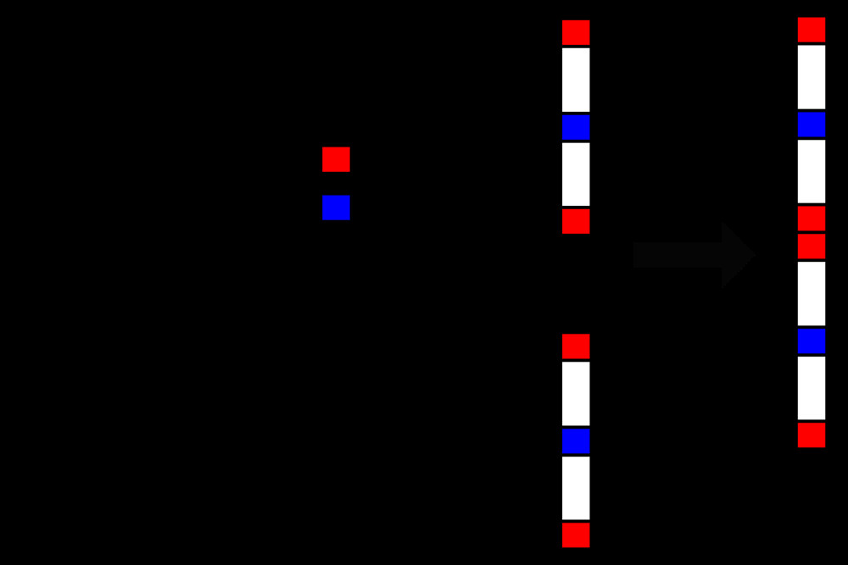
Figure 1: Diagram of the ancestral chromosome fusion that created human Chromosome 2. The two shorter chromosomes found in other apes (right) fused end-to-end, leaving behind telltale markers: extra telomere DNA (red) in the middle of the resulting human chromosome and a redundant, inactivated centromere (blue)[19]. All other great apes still carry these as separate chromosomes, whereas our lineage merged them into one.
The correspondence is striking: the DNA sequence of human chromosome 2 aligns with two separate chromosomes in chimpanzees, which researchers call 2A and 2B in the ape genome[4]. The genes on those two ape chromosomes are found on our single chromosome 2, in the same order. The fusion hypothesis, first proposed decades ago, was confirmed when the human genome was sequenced and these remnants were located. As one genetics paper concluded, “we conclude that the locus ... marks the point at which two ancestral ape chromosomes fused to give rise to human chromosome 2”[21]. This is like finding a seam in a piece of fabric – evidence that what was once two pieces became one. Such a unique change (a fusion of two whole chromosomes) is extremely unlikely to happen in exactly the same way in two separate lineages. The most logical explanation is that it happened once in a common ancestor. All humans carry the fusion, and all chimps, gorillas, and orangutans carry the unfused version, which fits perfectly with the idea that the fusion occurred in the human line after it diverged from that common ancestor[17][22]. Chromosome 2’s peculiar structure is thus a molecular fossil, capturing a moment in our evolutionary history and reminding us of our shared ancestry with other apes.

Genomic Relics: Endogenous Retroviruses and Shared DNA Errors
If two books have the same typo in the same place, chances are they weren’t independently produced – more likely, one copied the other or both copied from the same source. The genomes of living organisms likewise contain “typos” and insertions that are best explained by common origin. Some of the most intriguing examples are endogenous retroviruses (ERVs) – fragments of viral DNA lurking in our genomes. When certain viruses (like retroviruses) infect a cell, they can splice a copy of their own genetic code into the host’s DNA. If that happens in a sperm or egg cell and doesn’t seriously harm the host, the viral DNA can be passed down to the host’s offspring as a permanent part of the genome[23][24]. Over generations, these viral remnants accumulate. In humans, a significant portion of the genome (by some estimates, anywhere from ~1% to up to 8%) consists of DNA from ancient viruses that struck our ancestors[25][26]. These are not active infections, just molecular echoes – the “fossilized” genomes of viruses from perhaps millions of years ago.
What’s fascinating is that we often find the exact same viral DNA insertions in the exact same genomic locations in different species. The odds of two different species being hit by the same virus in the same spot in their DNA by pure chance are astronomically low, especially when you consider thousands of possible insertion sites. So when scientists discovered that humans and chimpanzees share many of these endogenous retroviruses in common locations, it provided smoking-gun evidence of common descent[27][28]. At least seven distinct instances of retroviral insertions are known to be present at the same locations in both human and chimp genomes[27][5]. In each case, the simplest explanation is that a retrovirus inserted into the DNA of a distant ancestor (before the human and chimp lineages split), and all descendants of that ancestor (including us and chimps) inherited that viral DNA “scar.” Species that are not descended from that ancestor won’t have the virus in that spot. For example, within the cat family, all small cats (like domestic cats, lynxes, etc.) share a particular retrovirus insertion that big cats (like lions or tigers) lack – implying the insertion happened after the small cats diverged from the big cats[29]. In primates, the pattern of shared ERVs maps neatly onto the evolutionary tree: humans and chimps share several that other more distant primates do not, all primates share others that, say, no non-primate has, and so on[5]. It’s exactly what we expect if the tree of life is real and viruses occasionally cut their signatures into the branches.
Endogenous retroviruses are just one category of shared genomic “mistakes.” Another involves pseudogenes – genes that once were functional in an ancestor but have been inactivated by mutations. They’re often dubbed “broken genes.” Because pseudogenes generally no longer have a function, mutations within them are neutral – they’re not weeded out by natural selection. This makes it likely that organisms will accumulate random changes in pseudogenes over time[30][31]. If two species possess the same pseudogene with the same inactivating mutations, the most straightforward explanation is that they inherited it from a common ancestor in which the original gene was first broken[32][33]. A classic example is a pseudogene shared among primates for one of the hemoglobin subunits. Humans have a defective copy of a hemoglobin gene (the psi-beta-globin pseudogene), and chimps, gorillas, and other primates have the identical crippled gene with the same deletions and errors in the same chromosomal location[34]. It stretches credulity to think that exactly the same disabling mutations would independently occur in multiple species – instead, the pseudogene was likely broken just once in a distant primate ancestor and passed down. Another case is a pseudogene related to an enzyme called 21-hydroxylase; both humans and chimpanzees carry a version that has an identical eight base-pair deletion rendering it nonfunctional[35]. Such congruence is like multiple descendants inheriting the same family heirloom – in this case, a broken heirloom. By examining which species share which pseudogenes, scientists can deduce branching order: for instance, if humans and Old World monkeys share a particular broken gene, then all apes (which fall between those groups on the tree) are predicted to have it as well[36]. This indeed is what we observe in countless cases. Shared endogenous retroviruses, pseudogenes, and other genomic flotsam form a trail of evidence that different species are related by descent, each piece marking a chapter of genetic history written long ago.

Conserved Proteins: Molecular Echoes Across Species
DNA is the blueprint, but proteins are the bricks and mortar of life. They carry out most of the functions in a cell, from catalyzing reactions (enzymes) to forming structures and signals. If two species descended from a common ancestor, not only will their DNA be similar, but the amino acid sequences of their proteins should also reflect that shared heritage. This is exactly what scientists have documented. Many proteins are astonishingly conserved across even distantly related organisms. A textbook example is the protein cytochrome c (mentioned earlier for its interchangeability). Cytochrome c is found in the mitochondria of all eukaryotes, playing a key role in the electron transport chain for energy production. Because it’s essential but can tolerate some change, scientists have compared its amino acid sequence across the spectrum of life. The pattern of similarity they found aligns perfectly with evolutionary relationships: closely related species have identical or nearly identical sequences, and the number of differences increases with evolutionary distance[3][37].
In fact, humans and chimpanzees have cytochrome c sequences that are 100% identical – not a single amino acid differs[3]. Our next nearest relatives, such as rhesus monkeys, have only a one–amino-acid difference in the cytochrome c protein[3]. More distant mammals like dogs or horses show around 10 differences[38], birds around 11 or so[39], and creatures like moths and yeast show a few dozen differences (reflecting their much more ancient divergence)[39]. The trend is clear: the further away on the evolutionary tree, the more amino acids differ. Importantly, there is no functional necessity for these sequences to be so similar. Cytochrome c can still do its job with many amino acid changes – in fact, there are astronomically many possible variations that would work[40][41]. The odds of two species independently arriving at the same sequence out of those countless possibilities are effectively zero[42][43]. Therefore, the simplest explanation for why a human and a chimp have identical cytochrome c (or why all mammals have very similar versions) is that they inherited it from a common ancestor. In statistical terms, the chance of humans and chimps coincidentally having the same 104-amino-acid sequence is less than 1 in 10^93 – practically impossible without common descent[42]. The data becomes even more powerful when you compare many species: the pattern of similarities in cytochrome c (and other ubiquitous proteins) produces a family tree that matches the tree derived from anatomy and fossils[44], reinforcing that we’re looking at genealogy, not just chemistry.
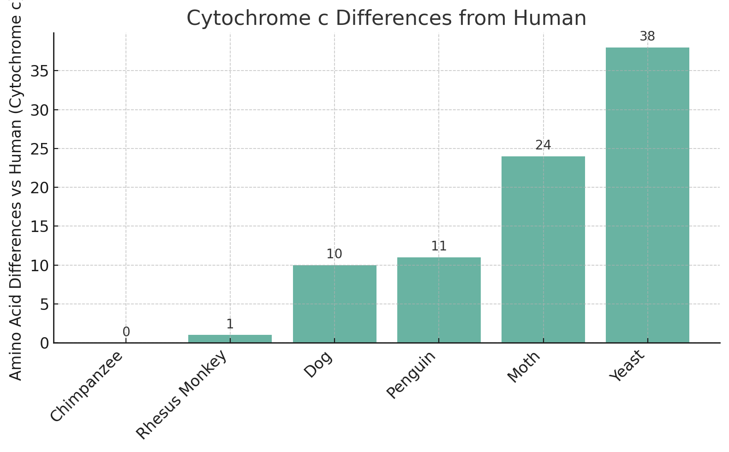
Figure 2: Amino acid differences in the cytochrome c protein between humans and various organisms (fewer differences means a closer relationship). Chimpanzees have zero differences from humans in this 104-amino-acid protein, rhesus monkeys only 1 difference, whereas more distantly related animals like dogs or penguins have around 10–11 differences, and very distant organisms like moths and yeast have dozens[45]. This quantitative pattern of increasing differences with evolutionary distance is strong evidence for common ancestry.
Cytochrome c is just one protein – the story repeats across the board. Hemoglobin, the oxygen-carrying protein in blood, also betrays our heritage. Humans and chimpanzees have identical hemoglobin protein sequences in both the alpha and beta chains that make up the molecule[46][47]. A gorilla’s hemoglobin differs from ours by only a single amino acid in each chain[46][47]. More distant mammals show more substitutions. These tiny differences in such a crucial protein demonstrate the branching of the primate family: chimps (and bonobos) are essentially blood brothers to us, gorillas a step further removed, and so on. The conservation extends to many less visible proteins as well. Histones, which help package DNA, or DNA/RNA polymerases, which copy genetic material, have core regions so conserved that a human and a bacterium share significant portions of these sequences[48]. In all living things, the ribosome (the molecular machine that builds proteins) is built from proteins and RNAs that are fundamentally alike – the core parts of ribosomal proteins in bacteria and in human cells can be closely aligned, indicating they descended from the same ancient template[48].
When scientists line up the protein sequences of a given gene from different species, what emerges is often a pattern of “graded” similarity – a hierarchy that mirrors traditional classification. For example, the insulin protein of pigs is more similar to that of whales (both are mammals) than to that of fish, and all vertebrate insulins are more similar to each other than any is to an insect insulin, and so on. These concentric circles of similarity were noted even in the mid-20th century by biochemists. It was another line of consilient evidence: life’s family tree was not only apparent in bones and organs, but also written in the letters of proteins. Today, with thousands of genomes sequenced, the massive flood of molecular data continues to confirm and refine the tree of life. Scientists can even quantify roughly how long ago species diverged by using molecular clocks – certain genes mutate at semi-regular rates, so the number of differences acts like ticks on a clock to estimate time since a last common ancestor[49][50]. While the concept of a strict clock is complex (different genes tick at different speeds), molecular timing has independently corroborated evolutionary timelines inferred from fossils, such as the split between human and chimp lineages mentioned earlier (on the order of a few million years).

Mapping the Tree of Life: DNA and the Evolutionary Family Tree
Perhaps the most profound outcome of comparing molecules across organisms is the realization that all life is related. We can take a gene present in many lineages – say, the gene that encodes ribosomal RNA, a centerpiece of the protein-making machinery – and compare its sequence in bacteria, archaea, plants, fungi, animals, etc. The similarities and differences allow us to construct a grand phylogenetic tree, a branching diagram that shows how all these groups are related. The result is not a collection of disconnected trees, but one big Tree of Life with three major trunks (the three domains of life: Bacteria, Archaea, and Eukaryotes) stemming from a common root[51]. In the 1970s, biologist Carl Woese pioneered this approach by sequencing ribosomal RNA from various microbes. He discovered that what we used to call “monera” or “prokaryotes” actually consisted of two very different groups (now Bacteria and Archaea) that are as genetically distinct from each other as either is from us[52][53]. This was a stunning revelation that only molecular data could provide, and it confirmed that life’s history traces back to a single origin – often termed the Last Universal Common Ancestor (LUCA). LUCA was not the first life form, but it’s the most recent one from which all current life descends. By definition, we can’t go further back with comparisons because no organisms older than LUCA are around to tell the tale.
When scientists use computational methods to build phylogenetic trees from DNA or protein sequences, they consistently find that the trees from different genes agree on the broad strokes of life’s relationships[54][55]. For example, a tree made from a mitochondrial protein like cytochrome b will group bats closer to horses than to birds (since bats and horses are both mammals), matching what morphology tells us[56]. These trees also reaffirm that certain quirks are universal: all living things use DNA/RNA, share a core set of 20 amino acids, and rely on the same basic cellular membranes (lipid bilayers)[48][57]. The universality and cross-confirmation give us confidence that we’re uncovering real evolutionary history. Modern genomics has taken this a step further with large-scale analyses: rather than single genes, researchers now compare hundreds or thousands of genes at a time. The picture that emerges is of a branching tree that goes back in time, occasionally with some twists (like gene-swapping among bacteria causing branches to cross early in evolution), but overall a coherent history of descent.
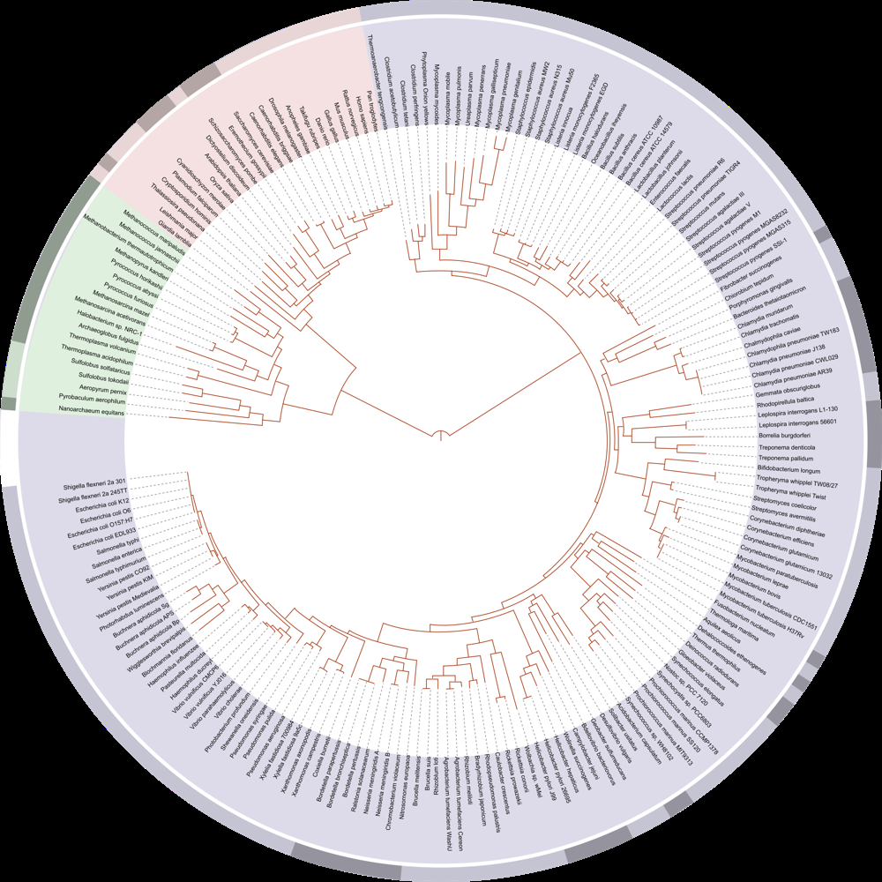
Figure 3: A phylogenetic tree of life based on genetic data (circular format). The center represents the last universal common ancestor, and radiating outwards are branches for Bacteria (blue), Archaea (green), and Eukaryotes (pink)[51]. Each tip of the branches is a species (names around the circle). Notably, the pink segment (at top-right) includes all animals, plants, and fungi – just a small cluster on the vast tree, illustrating that most of life’s diversity is microbial. Such trees, constructed from DNA/RNA sequences, visually demonstrate how all life forms are connected by common ancestry.
Crucially, molecular phylogenies have answered questions that fossils and anatomy alone could not. They’ve helped identify our closest relatives (for instance, confirming that chimpanzees and bonobos are closer to humans than gorillas are[58], resolving a longstanding question). They’ve traced the origins of major adaptations (like the evolution of vision: despite eyes evolving in different forms – camera eyes, compound eyes – virtually all rely on related opsin proteins for light detection, pointing to a common origin of light-sensing molecules[59]). DNA comparisons also let us quantify relatedness in a way classical biology couldn’t. We can say exactly how many genetic differences separate, say, a human and a mouse, and use that to estimate how long ago their ancestors diverged. In many cases, these molecular clocks have beautifully dovetailed with geological and fossil evidence (for example, DNA suggests our common ancestor with rodents lived tens of millions of years ago, and indeed the earliest placental mammal fossils date to around that time).
All these molecular revelations reinforce a single, elegant conclusion: the immense diversity of life today is all evolved variation on an ancestral theme. The tree of life isn’t just a metaphor – it’s a real, tangible pattern we can read in the molecules of our bodies. Every gene sequence, every protein structure that we compare is a line in the manuscript of evolution, sometimes revealing deep chapters of the past.

Epilogue: The Tapestry of Life
In the end, the story that molecular biology tells us is both humbling and inspiring. Humbling, because it reminds us that Homo sapiens is not a breed apart, but one twig on the flourishing tree of life. The very structure of our DNA and the proteins in our cells are not unique novelties, but inherited legacies shared widely – we carry the history of microbes, fish, and apes within our own genome. And it’s inspiring because it highlights the unity underlying nature’s apparent diversity. The next time we marvel at a bird in flight or a tiny bacterium under a microscope, we can appreciate that on the most fundamental level, that bird and that bacterium are distant cousins of ours. The shared endogenous retroviruses in our DNA, the universal genetic code, and the common proteins that run our metabolism all speak to a profound relatedness. Charles Darwin closed On the Origin of Species reflecting on “grandeur in this view of life... that, whilst this planet has gone cycling on, endless forms most beautiful and most wonderful have been, and are being, evolved.” Today, the grandeur of that view is illuminated in neon by molecular evidence. We now read evolutionary history in A, C, G, and T, and the message is unmistakable: all life is family. Understanding this enriches our connection to other living beings and to the natural world. It tells a grand narrative of resilience and creativity – from a single primordial cell billions of years ago arose the tapestry of ecosystems and organisms we see now, all related, all kin. In the tiniest DNA sequence or the simplest protein fold, there is a trace of our shared origin, a reminder that life on Earth, in all its variety, sings variations on one ancient, enduring theme.

[1] [3] [4] [5] [6] [7] [8] [15] [17] [18] [21] [22] [26] [37] [48] [49] [50] [52] [53] [55] [57] [59] Evidence of common descent - Wikipedia
https://en.wikipedia.org/wiki/Evidence_of_common_descent
[2] [11] [12] [13] [14] [16] Comparing Chimp, Bonobo and Human DNA | AMNH
https://www.amnh.org/exhibitions/permanent/human-origins/understanding-our-past/dna-comparing-humans-and-chimps
[9] [10] [23] [24] [25] [27] [28] [29] [30] [31] [32] [33] [34] [35] [36] [40] [41] [42] [43] [44] [54] [56] 29+ Evidences for Macroevolution: Part 4
https://www.talkorigins.org/faqs/comdesc/section4.html
[19] [20] Chromosome 2 - Wikipedia
https://en.wikipedia.org/wiki/Chromosome_2
[38] [39] [45] [46] [47] [58] Are Humans More Closely Related to Gorillas or to Chimpanzees? by Amir Aslam
https://www-personal.umd.umich.edu/~jcthomas/JCTHOMAS/Student%20Papers%201996/A.Aslam.html
[51] File:Tree of life SVG.svg - Wikimedia Commons
https://commons.wikimedia.org/wiki/File:Tree_of_life_SVG.svg

