Authority in Catholicism, Protestantism, and Eastern Orthodoxy: A Comparative Exploration
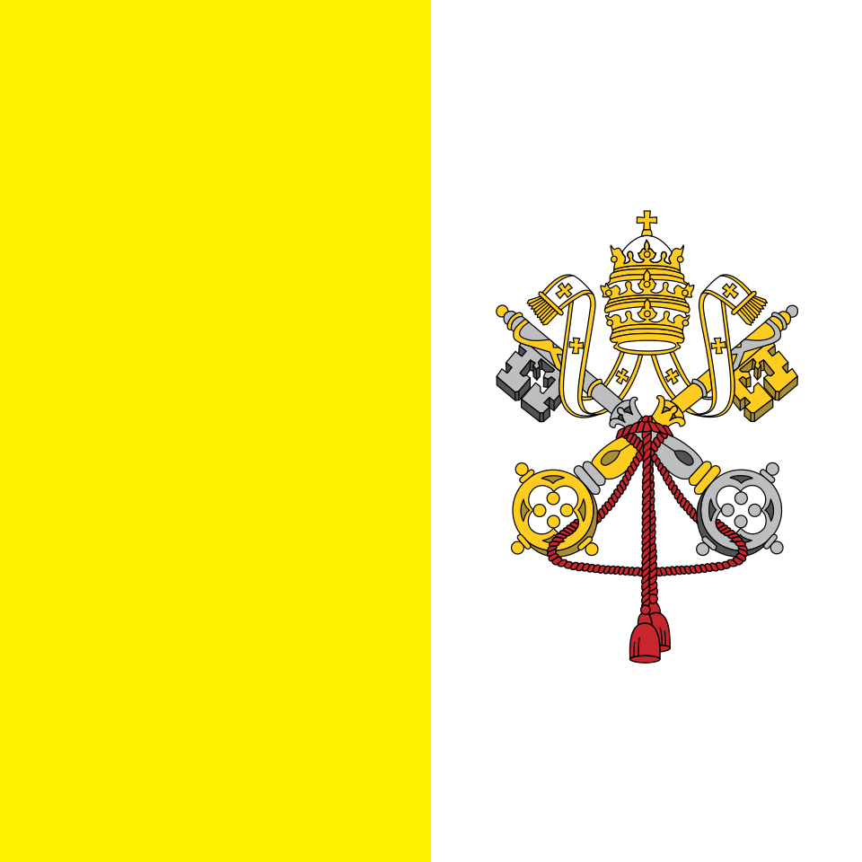
The crossed keys and papal tiara – traditional symbols of the Papacy’s authority.
Written and collected by Zia H Shah MD

Catholicism: The Primacy of Papal Authority
Catholicism centers its ecclesial authority on the papacy – the office of the Bishop of Rome, believed to be the successor of the Apostle Peter. This principle, called papal primacy, has deep historical roots. From early on, the Church of Rome was held in special esteem: around 110 AD, Ignatius of Antioch referred to the Roman church as “presiding” in love and faith among other churches[1]. By the late 2nd century, St. Irenaeus of Lyon famously wrote that “every Church should agree with this Church [of Rome], on account of its pre-eminent authority”[2]. Early Christian communities saw Rome’s bishop as a focal point of unity, given Rome’s association with Peter and Paul and its status in the Empire[3][4].
Over the centuries, the Pope gradually gained a singular leadership role. After Christianity’s legalization (4th century), the Bishop of Rome often acted as an arbiter in doctrinal disputes. For example, the Council of Chalcedon (451) acclaimed Pope Leo I’s doctrinal letter by exclaiming, “Peter has spoken through Leo!” – reflecting the belief that Rome guarded apostolic truth. Medieval developments further solidified papal authority. Popes like Gregory VII asserted the power to depose secular rulers, and the papal tiara came to symbolize not just spiritual leadership but temporal influence. By 1054, divergent views on Rome’s claims contributed to the East–West Schism, with the Eastern Church rejecting the Pope’s supreme jurisdiction. In response to the Protestant Reformation a few centuries later, the Catholic Church doubled down on papal authority and tradition as coequal with Scripture at the Council of Trent (1545–1563).
Catholic doctrine formally defined the Pope’s authority in the First Vatican Council (1870). Vatican I’s dogmatic decree Pastor Aeternus declared that the Pope holds “full and supreme power of jurisdiction over the whole Church, not only in matters of faith and morals, but also in discipline and government of the Church”[5][6]. It taught that this power is “ordinary and immediate” in every church and that appeals to any authority above the Pope (such as an ecumenical council apart from papal approval) are invalid[7][8]. Vatican I also defined papal infallibility: when the Pope speaks ex cathedra (with full authority, intending to define a doctrine for all Catholics on faith or morals), he is preserved from error by the Holy Spirit. This extraordinary claim was justified by Catholic theologians through Jesus’ words to Peter (“You are Peter, and on this rock I will build my Church… I will give you the keys of the kingdom” in Matthew 16:18–19) and Luke 22:32 (“I have prayed for you [Peter] that your faith may not fail”). Indeed, Vatican I cited earlier councils and popes to show continuity, including the medieval Council of Florence (1439) which stated: “The Roman Pontiff is the true Vicar of Christ, the head of the whole Church and the father and teacher of all Christians; to him was committed…full power of tending, ruling and governing the whole Church”[9].
In practice, Catholic authority operates as a teaching hierarchy (Magisterium). The Pope in communion with the bishops defines doctrine and guards the deposit of faith. Ecumenical councils are considered authoritative only if confirmed by the Pope. For example, Pope Pius IX unilaterally defined the Immaculate Conception of Mary in 1854, and Vatican I itself was convened and ratified by Pius IX. The Pope’s pronouncements (e.g. papal encyclicals) guide Catholic belief, though only infrequently are they infallible definitions. More often, the Pope and bishops together exercise ordinary magisterium to interpret Scripture and Tradition. In the modern age, Vatican II (1962–65) reaffirmed papal primacy but also emphasized the collegial unity of the bishops with the Pope (teaching that the college of bishops, never apart from its head, also bears the Church’s infallibility in teaching[10][11]). Still, the Pope remains the supreme pastor. A Catholic today sees the Pope as visible sign of unity and final human authority in the Church – a role Catholics believe was instituted by Christ for the sake of doctrinal certainty and unity of governance[12][13]. As one medieval motto put it: “Ubi Petrus, ibi ecclesia” – where Peter (the Pope) is, there is the Church.

Protestantism: Sola Scriptura – Scripture’s Supreme Authority
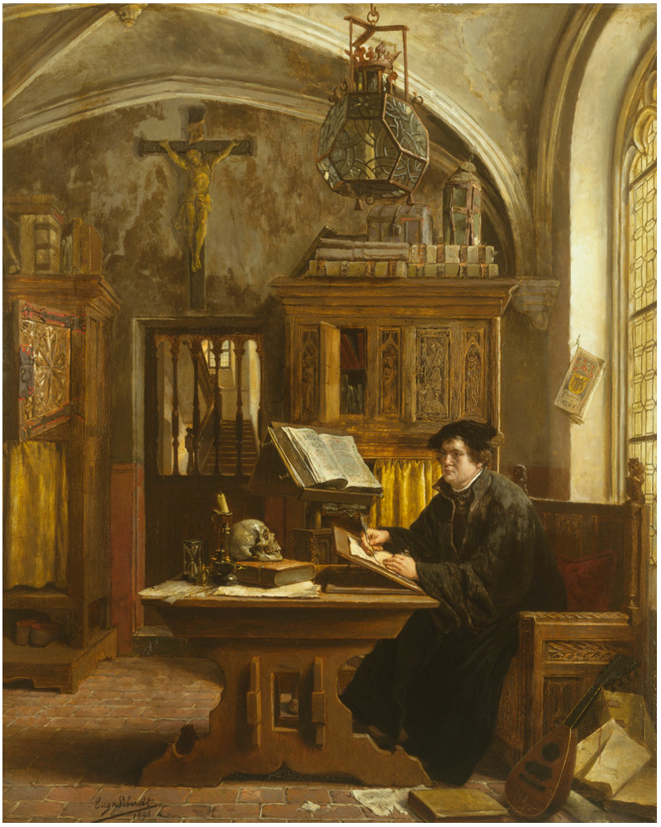
Eugene Siberdt’s painting “Martin Luther Translating the Bible” (1898) depicts Luther at Wartburg Castle in 1521. The open Bible symbolizes the Reformers’ principle that Scripture alone is the final authority.
In contrast to Catholicism’s triad of Scripture-Tradition-Magisterium, mainstream Protestantism from the 16th century affirmed “sola scriptura,” the doctrine that Scripture alone is the ultimate authority for Christian faith and practice. This was a cornerstone of the Protestant Reformation. Reformers like Martin Luther argued that the Church had no right to impose doctrines or practices not grounded in the Bible. At the famous Diet of Worms (1521), when pressed to recant his teachings, Luther refused unless proven wrong by Scripture: “Unless I am convinced by Scripture and plain reason – I do not accept the authority of popes and councils, for they have contradicted each other – my conscience is captive to the Word of God. I cannot and I will not recant anything, for to go against conscience is neither right nor safe”[14]. This defiant speech illustrates the Protestant conviction that even the highest church authorities must yield to the Bible. The Protestant cry became “Ad Fontes” (to the sources), leading to vernacular Bible translations (Luther’s German Bible, the English Tyndale and King James Bibles, etc.) so that all believers could read Scripture themselves.
Historically, sola scriptura emerged as a response to what Reformers saw as abuses of church authority and extra-biblical traditions in late medieval Catholicism. The Lutheran Augsburg Confession (1530) thus pledges not to teach anything “against Scripture.” The Reformed Westminster Confession of Faith (1646) similarly declares that in all religious controversies, “the supreme judge by which all controversies of religion are to be determined…can be no other but the Holy Spirit speaking in the Scripture”[15]. According to the Westminster Confession, Scripture is self-sufficient and perspicuous (clear in essential matters) – “the whole counsel of God…is either expressly set down in Scripture, or by good and necessary consequence may be deduced from Scripture,” and “nothing at any time is to be added” to it[16][17]. Early Protestants did value the historic creeds and respected Church Fathers, but they insisted these authorities be tested against Scripture. For instance, John Calvin cited St. Augustine’s maxim: “Whatever they may adduce from any quarter, Augustine is always prompt with the reply: ‘Let us not hear, I say, This is true, this is what I say, but rather, Thus says the Lord in the Scriptures’.” This encapsulated the Reformation mindset.
Protestants often argue that sola scriptura itself resonates with early Christian thought. They point to Church Fathers like St. Athanasius, who in debating heretics remarked that “divine Scripture is sufficient above all things”[18] for the declaration of truth, and St. Vincent of Lérins who acknowledged Scripture’s completeness (“the canon of Scripture is complete, and sufficient of itself for everything”[19]) even as he counseled respect for tradition. Such quotes are used (sometimes contentiously) to show that reliance on Scripture was central even in antiquity. The key difference is that Protestants deny any infallible interpreter on earth – the Bible itself is the only infallible norm. All church leaders, confessions, and traditions have authority only insofar as they agree with Scripture.
In practice, mainstream Protestants do have church structures and subordinate authorities. Lutheran and Reformed churches, for example, produced authoritative confessions (Augsburg, Westminster, Heidelberg Catechism, etc.) and have synods or assemblies. But these confessional statements explicitly submit themselves to Scripture. If a teaching “cannot be proved by Scripture,” it cannot be required as doctrine[20]. Many Protestant denominations hold that councils and pastors possess a fallible authority – respected but always reformable by the Word of God (ecclesia reformata, semper reformanda). This approach led, historically, to a plurality of Protestant interpretations and denominations. Protestants acknowledge the risk of fragmentation, yet see it as the cost of faithfully obeying Scripture and conscience rather than human decrees. They emphasize that the core teachings of salvation are clear in Scripture (an idea called the clarity of Scripture), so that an ordinary believer “in a due use of ordinary means, may attain to a sufficient understanding” of what must be believed[21].
Thus, in today’s Protestant communities, a sermon’s or council’s validity is assessed by Biblical fidelity. A concrete example: when debates arise (say, about moral questions or doctrinal points), Protestants will ask, “What do the Scriptures say?” and often engage in Bible study to resolve the issue. While one Protestant body may appeal to its own tradition or reason (e.g. Anglicanism’s “Scripture, Tradition, and Reason” triad or Wesleyan Methodists’ use of experience), Scripture remains the final court of appeal. This principle of sola scriptura continues to define Protestant identity over against the Catholic and Orthodox claim that Holy Tradition or Magisterium carries co-authority. It is a radically text-centered model of authority, aiming to safeguard the transcendence of divine revelation over all human institutions.

Eastern Orthodoxy: Authority in Holy Tradition and Councils
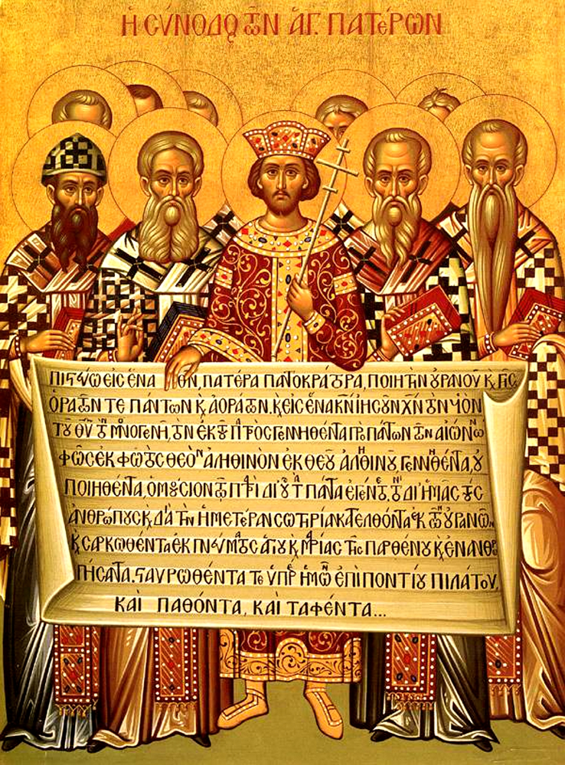
Icon of the First Ecumenical Council (Nicea, 325 AD). Emperor Constantine (center) and the bishops hold the Nicene Creed. Eastern Orthodoxy views the Ecumenical Councils of the early Church as paramount authorities, guided by the Holy Spirit.
The Eastern Orthodox Church bases authority on the Holy Tradition of the Church, manifested especially through the collegial leadership of bishops in Councils. In contrast to the centralized papacy of Catholicism and the scriptural sola of Protestantism, Orthodoxy operates with a model often described as conciliarity (in Greek, synodality or the concept of sobornost, a spiritual harmony). The Orthodox ideal is that the Church’s truth is confirmed by the consensus of the faithful – across time and space – rather than by one office or one text alone. As Bishop Kallistos (Timothy) Ware explains, Orthodoxy “believes that the council is the chief organ whereby God has chosen to guide His people, and it regards the Church as essentially a conciliar Church”[22]. In councils, “no single member arbitrarily imposes his will upon the rest, but each consults with the others…they all freely achieve a common mind. A council is a living embodiment of the Church”[23]. This approach harkens back to the Apostolic Council of Jerusalem (Acts 15), where the apostles collectively discerned God’s will, declaring, “It seemed good to the Holy Spirit and to us…”[24].
Historically, Eastern Orthodoxy traces its authority structure to the early undivided Church. The first Seven Ecumenical Councils (from Nicea in 325 to Nicea II in 787) hold a pride of place in defining Orthodox dogma (e.g. the Trinity, Christ’s two natures, the veneration of icons). These councils were gatherings of bishops from throughout the Christian world (with significant input from the Eastern patriarchates and the Bishop of Rome before schism). Orthodox Christians view these councils’ decrees as infallible expressions of Holy Tradition, precisely because they believe the decisions were accepted by the whole Church under the Spirit’s guidance. A famous Orthodox maxim attributed (perhaps apocryphally) to St. Vincent of Lérins captures how Tradition is discerned: “hold that faith which has been believed everywhere, always, by all”[25]. In other words, truth is what the universal Church has consistently taught. Novelty is a red flag. This Vincentian Canon means Orthodoxy highly values antiquity and universality in doctrine: if a teaching appears new or localized, it is viewed with suspicion.
Leadership in Orthodoxy is vested in a college of bishops who are successors to the Apostles (this is shared with Catholicism’s belief in apostolic succession). However, Orthodox bishops govern autocephalous (self-headed) Churches – such as the Russian, Greek, Serbian Orthodox Churches – none of which claims authority over the others in the way the Pope claims over all. The Ecumenical Patriarch of Constantinople is accorded a primacy of honor (first among equals) but not a jurisdictional supremacy. Each local church’s synod of bishops is the highest authority for that church, and pan-Orthodox decisions require agreement among all sister churches. This decentralized structure is rooted in early canons (like Canon 6 of Nicea, which spoke of the ancient patriarchates having their own regions of authority). Orthodox ecclesiology often quotes Cyprian of Carthage (3rd century): “The episcopate is one, of which each bishop holds his part in solidarity with the whole”[26][27]. In Cyprian’s imagery, the Church is like one tree with many branches or one sun with many rays – many bishops, but forming one Church in unity. No single branch can claim to be the whole tree. This patristic idea undergirds Orthodox wariness toward unilateral papal power.
Orthodox theologians argue that it is not any one hierarchy alone, but the entire body of the Church – laity and clergy together – that guards the faith. A striking expression of this is found in the Encyclical of the Eastern Patriarchs (1848), written in reply to Pope Pius IX. It states: “Among us, neither Patriarchs nor Councils could ever introduce new teaching, for the guardian of religion is the very Body of the Church, that is, the people themselves.”[28][29]. This reflects how Orthodoxy understands Christ’s promise that the Holy Spirit would lead the Church into all truth – not via one infallible office, but through the Church as a whole preserving Apostolic faith. Indeed, history shows that councils not received by the whole Church are not considered valid in Orthodoxy. For example, the reunion Council of Florence (1439) – which agreed to papal primacy and doctrinal compromises – was rejected by the Eastern clergy and laity; thus it “failed” and is not part of Orthodox Tradition. In Orthodox eyes, reception by the faithful is the final seal on a council’s authority.
Within Holy Tradition, Scripture holds a place of highest honor – it is the inspired Word of God – yet it is within Tradition that Scripture is interpreted. Orthodoxy often says Scripture is the core of Tradition. They accuse sola scriptura of being too subject to individual interpretation; instead, they appeal to the consensus of the Church Fathers as a guide for understanding Scripture. The Orthodox study of theology is deeply patristic. For instance, Orthodox catechisms frequently cite St. John Chrysostom, St. Basil the Great, and other Fathers alongside Scripture. The church’s liturgy itself, unchanged over centuries, is seen as a vehicle of Tradition – conveying the faith in prayers, hymns, and rites.
In the contemporary Orthodox Church, authority is exercised through synods of bishops. When issues arise (like modern bioethical questions or inter-Orthodox disputes), the heads of autocephalous churches meet in council. A recent example was the Holy and Great Council of 2016, where many Orthodox bishops convened to discuss pressing issues – a kind of modern ecumenical council, though some churches did not attend, illustrating the challenges of conciliar unity today. Despite administrative difficulties, Orthodox theology maintains that the Church cannot fall into error as a whole because the Holy Spirit preserves it through a balance of hierarchy and lay witness. As one 19th-century Russian theologian, Alexei Khomiakov, wrote, no single bishop or synod by itself is infallible, but the whole people of God – in unity with their bishops – cannot go astray in faith[30][31]. This concept is sometimes termed “infallibility of the Church” rather than of a person. It is a mystical conviction that Truth is confirmed by unanimity in love, not by decree of a single office.
Thus, Eastern Orthodoxy’s authority structure might be summarized as “Scripture and Tradition as understood by the consensus of the Fathers, expressed in Councils, and lived in the worshiping life of the Church.” It is both conservative (looking back to the first millennium for normative doctrine) and communal. In an Orthodox parish today, one sees this authority in the centrality of the Divine Liturgy (which transmits belief through ancient prayers), in reverence for bishops (as overseers who must themselves obey Tradition), and in the use of icons and saints’ writings as educational tools – all under the belief that they convey the one unchanged Apostolic faith. When doctrinal questions arise, Orthodox faithful ask: “What do the Fathers say? What have the councils decreed? Is this in line with the Creed and the Church’s prayer?” The answer is sought not innovatively but by reconnecting with the past consensus. As Metropolitan Kallistos Ware succinctly put it, “the Orthodox Church is essentially a conciliar Church”[22], where authority is a shared synergy of Scripture, tradition, and the Holy Spirit working through the whole body of believers.

Conclusion: Unity and Diversity in Christian Authority
The differing authority frameworks of Catholicism, Protestantism, and Eastern Orthodoxy each developed through specific historical and theological trajectories. Catholicism emphasizes a living, hierarchical continuity – the Pope and bishops as inheritors of Peter and the Apostles, carrying Christ’s authority to teach and bind. This gives the Catholic Church a clear center of unity and an authoritative voice to decide debates (as seen in papal encyclicals or councils ratified by the Pope). Protestantism, in turning to sola scriptura, sought to democratize authority in a sense – placing the infallible guide not in any human office but in the Bible itself, accessible to all. This upholds the primacy of God’s Word and individual conscience[14], but it also relies on each community (and ultimately each believer) to interpret that Word, leading to a mosaic of denominations. Orthodoxy offers yet another model: a reliance on the Church’s organic continuity (Holy Tradition), tested by consensus over centuries. Its authority structure is neither centralized in one man nor entirely de-centralized; it is “polycentric,” with unity maintained through shared faith and sacramental life rather than a single governing head.
Importantly, none of these traditions operates in absolute isolation from the others’ concerns. For instance, the Catholic Church since Vatican II has stressed collegiality and invited lay participation, acknowledging that truth is best understood in communion (an echo of Orthodox concerns). Many Protestants now engage critically with Church history and tradition, recognizing that Scripture must be read in context and with wise counselors – a nuance to sola scriptura sometimes called “prima scriptura” (Scripture first). And the Orthodox Church, while staunch in preserving ancient dogmas, has had to address new issues (from bioethics to modern governance) by convening synods that function in some ways like the Catholic Magisterium. All three traditions affirm that Jesus Christ is the ultimate head of the Church; their differences lie in how His guidance is mediated in the community.
For a seeker or a participant in interfaith dialogue, understanding these frameworks is key to appreciating each tradition’s self-identity. Each framework has its rationale and spiritual appeal: the Catholic finds assurance in a tangible shepherd who can definitively say “yes/ no” on doctrinal matters, believing this guards the Church from fragmentation (“one faith, one baptism, under one visible head”[32][33]). The Protestant finds security in the unchanging Word of God in Scripture, a word that stands above all cultures and councils – “the grass withers, the flower fades, but the Word of our God stands forever” – and thus resists any merely human traditions that might cloud the gospel. The Orthodox believer rests in the continuity of the apostolic faith alive in the worship and consensus of the Church, trusting the Holy Spirit not to one man or one book interpreted in isolation, but to the whole people of God over time.
In the end, these approaches are not merely institutional but theological. They reflect different understandings of how Christ governs His Church and how the Holy Spirit preserves truth. Engaging with them in a neutral, analytical way – as we have here – allows us to see the internal logic of each position. Rather than caricaturing papal authority as “authoritarian,” or sola scriptura as “chaotic private interpretation,” or Orthodox conciliarity as “inefficient and antiquated,” we discern that each arose from sincere attempts to secure the Church’s fidelity to Christ. Appreciating this can foster mutual respect. A Catholic can admire the Protestant love of Scripture; a Protestant can respect the Orthodox love of Tradition; an Orthodox can acknowledge the Catholic concern for unity and clear teaching – and vice versa.
All three traditions, in their best form, seek to answer the question: By what authority do we teach and believe? – and all ultimately answer, “By the authority of Jesus Christ, transmitted through the means He has given us”. They differ on what those means are: an ever-living apostolic office (Catholicism), the written apostolic testimony in Scripture (Protestantism), or the apostolic communion of the whole Church in the Spirit (Orthodoxy). By studying their historical evolution and rationale, as we have done, one gains a richer understanding of Christian history itself. And in today’s context, such understanding is a prerequisite for any fruitful interfaith dialogue among Christians. It enables conversation partners to ground their discussions in knowledge and empathy – seeing that each model of authority, though distinct, emerged from a desire to faithfully preserve what each community had received. In that sense, all three share a common hope: to hand on the truth of the Gospel for future generations. As the Apostle Paul wrote, “Guard the good deposit that has been entrusted to you, by the Holy Spirit who dwells within us” (2 Tim 1:14). The interpretations of how to guard that deposit may vary, but the earnest commitment to doing so is something that Catholics, Protestants, and Orthodox alike earnestly affirm.
Sources:
- Irenaeus of Lyon, Against Heresies 3.3.2 (c. 180 AD) – on Rome’s preeminent authority[2].
- Ignatius of Antioch, Epistle to the Romans (c. 107 AD) – addressing the Church “which presides” in love[1].
- First Vatican Council – Pastor Aeternus (1870), ch.3–4 – defining papal primacy and infallibility[8][9].
- Westminster Confession of Faith (1646), ch. 1 – on Scripture’s supremacy over councils and traditions[15].
- Martin Luther at the Diet of Worms (1521) – quoted in Luther’s Works, vol.32, p.112: “my conscience is captive to the Word of God…”[14].
- Athanasius of Alexandria, De Synodis (359 AD) – “divine Scripture is sufficient above all things”[18].
- Encyclical of Eastern Patriarchs (1848) – “Neither Patriarchs nor Councils could ever introduce new teaching… the people itself” guards the faith[28][30].
- Kallistos Ware, The Orthodox Church (1963) – on the Church as “essentially conciliar”[10] and the first Council of Jerusalem as model[24].
- Vincent of Lérins, Commonitorium (434 AD) – “hold that faith which has been believed everywhere, always, by all”[25].
- Cyprian of Carthage, On the Unity of the Church (251 AD) – on the one episcopate held collectively by many bishops[26].

[1] Church Fathers: St. Ignatius of Antioch | Catholic Culture
https://www.catholicculture.org/commentary/church-fathers-st-ignatius-antioch/
[2] St. Irenaeus: Against Heresies: Book III - Christian Classics Ethereal Library
https://ccel.org/ccel/irenaeus/against_heresies_iii/anf01.ix.iv.iv.html
[3] [4] History of papal primacy - Wikipedia
https://en.wikipedia.org/wiki/History_of_papal_primacy
[5] [6] [7] [8] [9] [12] [13] [32] [33] Decrees of the First Vatican Council - Papal Encyclicals
https://www.papalencyclicals.net/councils/ecum20.htm
[10] [11] [22] [23] [24] Met. Kallistos (Ware). The Orthodox Church - Chapter 1
https://readeralexey.narod.ru/ENGLISH/Ware1.html
[14] Martin Luther's Life: The Imperial Diet of Worms
https://www.luther.de/en/worms.html
[15] [16] [17] [20] [21] Providence Presbyterian Church: Troy, IL > Westminster Confession of Faith
https://www.providencepres.net/westminster-confession-of-faith
[18] CHURCH FATHERS: De Synodis (Athanasius)
https://www.newadvent.org/fathers/2817.htm
[19] [25] CHURCH FATHERS: Commonitorium (Vincent of Lerins)
https://www.newadvent.org/fathers/3506.htm
[26] [27] CHURCH FATHERS: Treatise 1 (Cyprian of Carthage)
https://www.newadvent.org/fathers/050701.htm
[28] [29] [30] [31] Apostolic Christianity and the 23,000 Western Churches: text - IntraText CT
https://www.intratext.com/IXT/ENG0803/_P68.HTM

