Timeline of Human Language Development
Written and collected by Zia H Shah MD

Abstract
Human language has a deep evolutionary history that intertwines biology, cognition, and culture. This essay surveys the timeline of human language development, from the pre-linguistic communication of our primate ancestors to the emergence of spoken language in early humans, the invention of writing in ancient civilizations, and the development of signed languages in modern communities. Integrating evidence from linguistics, anthropology, and biology, we explore how anatomical innovations (e.g. the descended larynx and the FOXP2 gene) and archaeological findings (such as engraved ochre and cave art) inform theories of when and how language arose. We discuss major hypotheses including protolanguage stages, gestural origins of language, and the concept of an innate universal grammar. The essay highlights comparative studies of primate communication and cognitive neuroscience insights which show that language engages specialized brain networks regardless of modality. We conclude with a reflective epilogue on the significance of language evolution in shaping human cognition and culture, emphasizing language as a defining faculty that propelled the success of our species.

Introduction
The origin and evolution of human language is a multidisciplinary puzzle that has fascinated scholars for centuries. Language is often seen as a defining feature of Homo sapiens, setting us apart from other animals in our capacity for abstract thought and complex social organization[1][2]. Because spoken language leaves no fossils, researchers must draw inferences from comparative primate behavior, the human fossil record, archaeological artifacts, and the reconstruction of ancient languages[3]. Early debates on language origins were largely speculative; in fact, in 1866 the Linguistic Society of Paris famously banned discussions on the subject due to lack of empirical evidence[4]. In recent decades, however, new evidence and methods have revitalized the study of language evolution[5]. Anthropologists unearthing symbolic artifacts, biologists decoding genes like FOXP2, neuroscientists mapping language areas in the brain, and linguists comparing languages have all contributed insights. This integrated approach allows us to sketch a timeline of human language development, from primordial communication systems to the linguistic diversity and complexity we observe today.
To structure this inquiry, we consider language in three modalities: spoken language (by far the oldest and most universal form), written language (a relatively recent invention in human history), and signed language (visual-manual languages fully equivalent to speech). We examine when each of these emerged and what evidence supports their development. We also review major theoretical frameworks, such as the idea of a protolanguage (a primitive precursor to modern language), the hypothesis of gestural origins (language beginning as manual gesture), and the concept of universal grammar (an innate, species-specific capacity for language). Throughout, key fossil and archaeological discoveries – from Neanderthal hyoid bones to ancient cuneiform tablets – are highlighted to ground the discussion in tangible evidence. By tracing the evolution of language, we gain insight into the cognitive leaps and cultural transformations that define humanity’s story.

Evolution of Spoken Language
Early Hominin Communication: The roots of human language likely extend back to the communication systems of our primate ancestors. Modern non-human primates have vocal and gestural signals, but these lack the generative grammar and open-ended vocabulary of human language[6][7]. For example, vervet monkeys use distinct calls to warn of snakes, eagles, or leopards, demonstrating symbolic reference (specific sounds tied to specific meanings)[6]. Great apes in the wild also communicate intentionally through gestures – a trait some researchers consider a clue to how human language could have begun in a gestural mode[8][9]. However, these animal communication systems are not compositional: they cannot combine elements to convey novel or complex messages in the way human language does[10][6]. Attempts to teach apes human-like language (such as sign language to chimpanzees or symbol boards to bonobos) have yielded only partial success. Trained apes acquire vocabularies of signs or symbols and can make simple requests, but they do not develop true syntax. The chimpanzee Nim Chimpsky, for instance, learned over 100 signs yet produced jumbled sequences like “give orange me give eat orange me eat orange…” without grammatical structure[11]. These findings underscore a qualitative gap between human language and other primate communication, suggesting that by the time of the last common ancestor of humans and chimpanzees (~6–7 million years ago), the ingredients for language were not yet present.
Anatomical Foundations for Speech: The evolution of spoken language required both neurological and anatomical changes as hominins diverged from other apes. Key adaptations included changes in brain organization (expansion of language-related areas) and the vocal tract. Early australopithecines (~4–2 million years ago) had ape-sized brains and probably communicated in ape-like ways. As brain volume increased in the genus Homo (e.g. Homo erectus around 2 million to 500,000 years ago), tool use and social living likely put a premium on better communication. The fossil skulls of some archaic humans hint at brain reorganization; endocasts show an expanded inferior frontal region (Broca’s area) in Homo habilis or erectus, which could correlate with rudimentary speech ability, though interpretations remain debated.
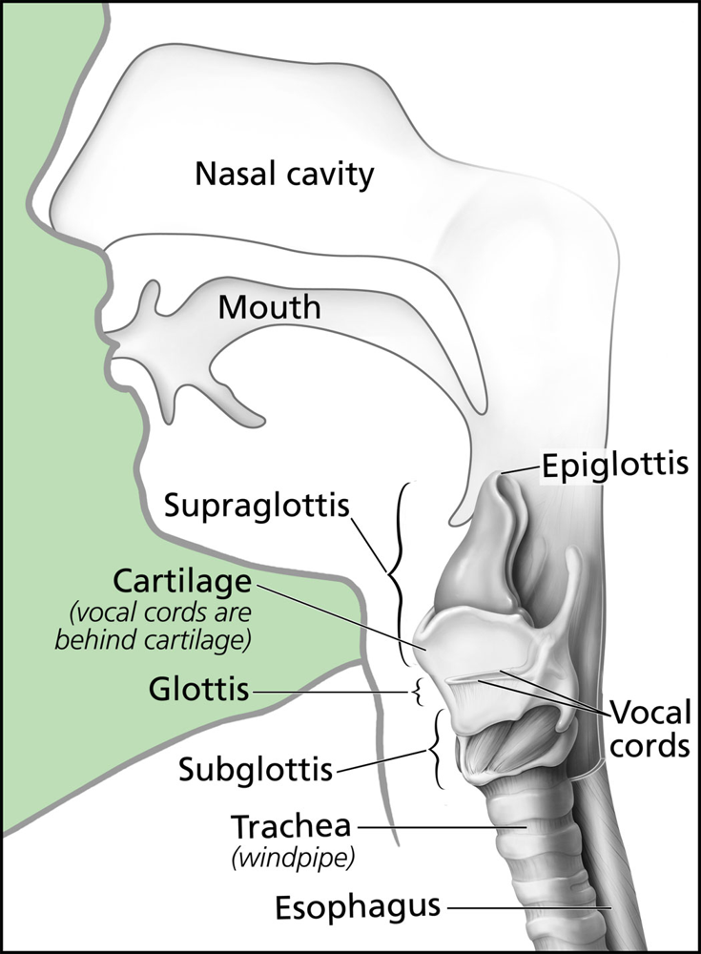
Diagram of the human vocal tract. In modern humans, speech is enabled by a low larynx position and a flexible tongue that together create a resonant cavity for articulate sounds. The larynx (voice box) contains the vocal cords and sits lower in the throat than in non-human apes, forming a two-part airway (oral and nasal) that allows the modulation of vowels[12][13]. In apes, the higher larynx and large air sacs (present in species like chimpanzees and gorillas) prevent them from producing the clear, steady vowels that characterize human speech[13]. Fossil evidence for when the human vocal tract assumed its modern form comes indirectly. A crucial bone is the hyoid, a U-shaped bone in the throat that supports the tongue and larynx. The discovery of a well-preserved Neanderthal hyoid (from Kebara, ~60,000 years ago) was a turning point. The Neanderthal hyoid is virtually identical in shape to that of Homo sapiens, suggesting Neanderthals had a similar laryngeal structure[14][15]. Advanced 3D modeling of the Kebara hyoid’s placement indicates Neanderthals lacked the big air sacs of apes and could likely produce a range of human-like vowel sounds[16][17]. Simulations of Neanderthal speech organs show they could generate recognizable vowel sounds like “ee” and “oo,” though some sounds (like a bright “ah”) may have had a different timbre due to a larger vocal cavity[17][18]. In short, by the mid-Quaternary period, at least one other hominin species (Neanderthals) possessed the anatomical prerequisites for spoken language. This implies that the anatomical evolution of the vocal tract (descent of the larynx, reshaped tongue and oral cavity) was largely in place by 300–400 thousand years ago, perhaps in the common ancestor of Neanderthals and modern humans.
Genetic Clues and Cognitive Capacity: While anatomy provides the physical means for speech, the emergence of language also required cognitive and neural innovations. A famous genetic finding is the FOXP2 gene, often dubbed the “language gene” (though it is not unique to language). A mutation in FOXP2 was identified in a family with heritable speech and language impairment, highlighting its role in orchestrating the fine motor control of speech (articulation) and possibly other language-related neural functions[19]. Notably, the Neanderthal genome revealed that Neanderthals shared with us the same two FOXP2 amino-acid changes that distinguish the human version from that of chimpanzees[19]. This initially suggested that Neanderthals had a similar genetic capacity for speech. However, more recent research indicates that modern humans have unique regulatory differences affecting FOXP2 expression in the brain[20]. In other words, although the FOXP2 protein was the same, gene activity in our brains may have diverged. These regulatory changes, coupled with archaeological evidence of much richer symbolic behavior in Homo sapiens compared to Neanderthals, suggest that fully modern language most likely evolved in our lineage after the split from Neanderthals[21]. Researchers infer that the capacity for language was present by at least 150,000–200,000 years ago, coinciding with anatomically modern Homo sapiens in Africa[22][23]. Early Homo sapiens sites from ~100,000 years ago show hints of symbolic thinking – for example, abstract engravings on red ochre blocks in Blombos Cave, South Africa – which support the presence of complex communication[22][24].
Determining exactly when true language began remains challenging. Some continuity theorists posit a gradual evolution from protolanguage: perhaps early Homo species had a simplistic, pidgin-like protolanguage (composed of isolated vocal signals or gestures) which only later developed full grammar[25][26]. Cognitive prerequisites like theory of mind (understanding others’ mental states) would have increased in tandem, allowing more sophisticated intentional communication[27][28]. Alternately, discontinuity theorists like Noam Chomsky argue for a relatively sudden emergence – a “Great Leap” – wherein a genetic mutation (perhaps enabling recursive thought or a neural “Merge” operation) gave rise to the language faculty roughly 100,000 years ago. Under this view, a single human population in Africa attained the full biological capacity for language, which then spread culturally and biologically as humans dispersed. While the timing is debated, it is clear that by ~50,000–70,000 years ago, anatomically modern humans were exhibiting behaviors (tool diversity, art, long-distance trade) that strongly imply linguistic communication. The later Upper Paleolithic “creative explosion” in Europe (~40,000 years ago) – famous for cave paintings, figurines, and musical instruments – likely reflects an expansion of cultures already enabled by language[29][30]. In contrast, Neanderthals at the same time show scant evidence of art or symbolism[30]. This discrepancy has been interpreted by some as indicating that complex language gave modern humans a cognitive and social edge. However, we must be cautious; absence of evidence is not evidence of absence. It may be that Neanderthals did have languages but left fewer symbolic artifacts, or that their languages were simpler. The consensus view today is that spoken language is unique to Homo sapiens (and possibly our close relatives like Neanderthals) and that it emerged as a product of both gradual primate evolution and one or more tipping-point innovations in cognition[31][32].
Protolanguage Theories: To bridge the gap from primate calls to full language, scholars propose intermediate stages. Linguist Derek Bickerton’s protolanguage hypothesis envisions early humans communicating with strings of nouns and verbs without syntax – somewhat like a child’s speech or a pidgin. An illustrative scenario (suggested by Bickerton) is an early hunter trying to recruit others for a big kill: encountering a large prey animal, he might rush back to camp and mimic the animal’s cry or perform a dramatic pantomime to indicate “there is big game out there”[33]. Such an act could convey a specific message (“come help hunt this creature”) without any grammar, relying on shared attention and intent. Over time, according to this view, these ad-hoc signals would conventionalize into stable words, and children’s minds – with an innate language instinct – would spontaneously inject grammatical structure into the protolanguage. Interestingly, creole languages provide a real-world analogy: when adults form a makeshift pidgin with limited grammar, the next generation of children often transforms it into a fully grammatical creole. This suggests that the human brain, especially in early childhood, naturally enriches linguistic input with rules. In evolutionary terms, the protolanguage stage might have lasted hundreds of thousands of years, gradually accruing complexity.
Gestural Origins and Multimodal Communication: One prominent theory posits that language began not as speech, but as gesture. This gestural origins hypothesis notes that great apes today use hand signals flexibly and intentionally (more so than vocalizations), and that early hominins, becoming bipedal with free hands, could have developed a sophisticated manual sign system[8][9]. Support for this comes from the fact that sign languages created by deaf communities are full languages with their own grammars, demonstrating the viability of purely visual-manual language[9]. If our ancestors communicated by signs and pantomime initially, it begs the question: why switch to vocal speech? Several possible advantages of speech are cited – for instance, vocal communication frees the hands for other tasks and can work in low light or at a distance (you can talk in the dark or while carrying objects)[34][35]. Conversely, gesture has its own advantages (e.g. silent signaling when stealth is needed, or communicating in noise). Some researchers believe early language was multimodal, combining vocal calls with gesture and facial expression, gradually shifting emphasis to the vocal component. There may have been an “unconscious transition” from primarily gestural to primarily spoken language over time[36][37]. The discovery of mirror neurons in monkeys – neurons that fire both when performing an action and seeing someone else perform it – has been speculatively linked to language evolution. Mirror neurons could have provided a neurological basis for understanding gestures and eventually mapping sounds to actions. While still theoretical, the gestural origin perspective reminds us that speech is not the only natural medium for language.
In summary, spoken language likely emerged through a complex pathway: grounded in primate communication, shaped by hominin anatomical changes, and refined by cognitive evolution. By the Late Pleistocene, our species had a fully developed linguistic capacity, which became a driving force in our success. All human groups in the present day, from hunter-gatherers to urban dwellers, possess rich spoken languages, implying that the last common origin of modern language predates the global dispersal of humans ~70,000 years ago[38][39]. Whether language emerged once or multiple times is still debated, but the prevailing view is that it arose in a single ancestral population (given that all languages share certain universal features and all humans share the necessary biological endowment)[40][41]. The stage was then set for the next major development in the timeline of language: the invention of writing.

Emergence of Written Language
Spoken language was humanity’s primary medium of communication for tens of thousands of years before any form of writing was conceived. Written language is not an innate biological ability but a cultural innovation – one that arose independently in a few cradles of civilization. Writing enables the recording and transmission of information across time and space, amplifying the power of language by preserving it. The timeline of writing is much more recent, beginning in the late Neolithic to Bronze Age. According to current evidence, writing was invented from scratch (independently) at least four times in human history[42]:
- Mesopotamia (Sumer): around 3400–3100 BCE, the Sumerians developed cuneiform, the world’s earliest known writing system, initially to keep economic records[42]. It began with pictographic signs pressed into clay tablets to represent commodities and counts.
- Egypt: by ~3250 BCE, Egyptian hieroglyphic writing emerged, likely independently, as suggested by differences in structure from Sumerian script[43]. Early hieroglyphs appear on labels and carvings associated with the first pharaohs.
- Indus Valley: a script was used between 2600–1900 BCE in the Indus civilization (in South Asia). The Indus script remains undeciphered and it’s uncertain if it encoded language phonetically or was a non-linguistic symbol system[44]. Its origins relative to Mesopotamia’s writing are unclear, but it could be a case of stimulus diffusion (inspiration from the idea of writing).
- China: writing in China developed by the Shang Dynasty, with the earliest confirmed evidence being oracle bone inscriptions around 1200 BCE (though signs on pottery from earlier may be ancestral)[42]. Chinese characters arose independently, following a logographic principle quite distinct from Mesopotamian or Egyptian systems[45].
- Mesoamerica: in the New World, the earliest writing (the Zapotec or Olmec glyphs) appeared by roughly 500–300 BCE, without any Old World influence[42]. The Maya later developed a fully elaborated script by the first centuries CE.
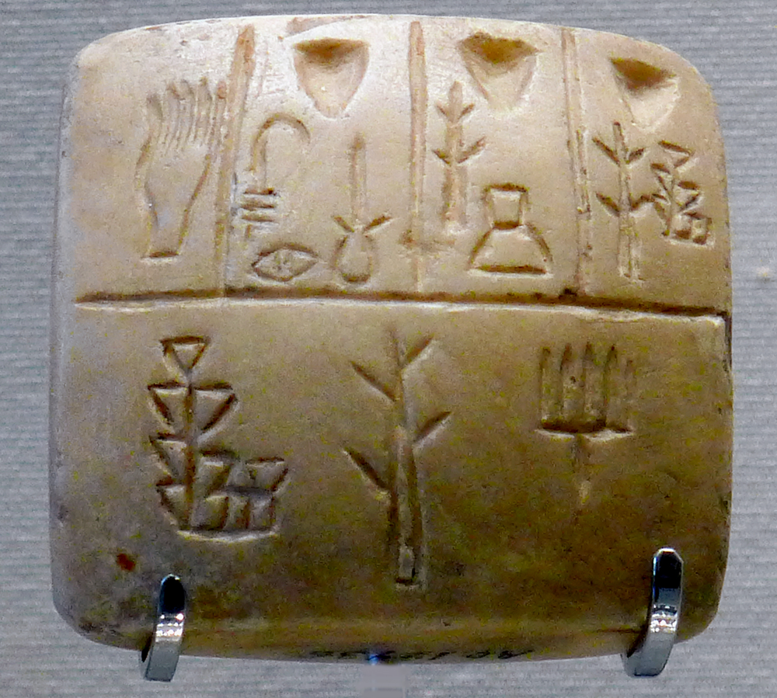
An early writing tablet with pictographic signs (late 4th millennium BCE, Uruk III period). Writing did not spring forth fully formed; it evolved out of proto-writing. In Mesopotamia, for example, a long tradition of using clay tokens to represent goods (dating back to 8000–6000 BCE) eventually led to impressing those tokens’ shapes on clay tablets – a pictographic record-keeping system[46][47]. Over centuries, these drawings became more abstract and standardized. In the tablet pictured above, simple images (a hand, an eye, a tree, etc.) are arranged in boxes – an early form of the cuneiform script in which each sign stands for a word or concept. Similar proto-writing existed elsewhere: Neolithic carvings like the Jiahu symbols in China (~6000 BCE) or the Vinča signs in Southeast Europe (~5000 BCE) show that humans were making symbolic marks long before true writing[48][49]. However, those did not develop into full writing systems in most cases. True writing is defined by encoding the language itself – typically through phonetic elements (sounds or syllables) or determinative symbols – rather than just conveying general ideas or tallies.
By the Bronze Age (circa 3300–1200 BCE), writing had matured in the major civilizations. Sumerian cuneiform and Egyptian hieroglyphs began to be used for not just accounting, but monumental inscriptions, literature, and correspondence, with a mix of logographic (word-sign) and phonetic elements[43][50]. This stage marks the end of prehistoric times and the beginning of recorded history. Writing allowed laws to be codified, religious texts to be set down, and narratives to be passed through generations with fidelity. The Phoenicians around 1100 BCE simplified writing by creating one of the first alphabets (where symbols represent individual sounds), which the Greeks and others adapted – a critical step that eventually leads to the scripts many of us use today (Latin, Cyrillic, etc.).
It is important to note that the development of writing was not an automatic or inevitable outcome of spoken language. Many human societies never invented writing on their own, yet their spoken languages were no less complex. Writing emerges in contexts where social complexity and administrative needs reach a threshold – for example, governing a large urban society or managing extensive trade. Once invented, writing spread through trade and conquest or was reinvented by analogy. For instance, early Japanese and Korean writing were inspired by Chinese characters, and the English alphabet is a descendant of the Greek via Latin letters, ultimately tracing back to the Phoenician script.
In the grand timeline, writing is a recent phenomenon: if anatomically modern humans have existed for ~200,000 years, writing has existed for only about 5,000, a mere 2.5% of that span. Yet its impact has been enormous in accelerating cultural evolution. Writing externalizes memory and allows communication beyond the speaker’s life or presence. It enabled the accumulation of knowledge (science, history, literature) far beyond what oral traditions alone could maintain. In evolutionary terms, writing is sometimes described as an “exaptation” – a cultural use of our visual and cognitive systems, piggybacking on our innate language capacity to create a new, learned skill. The invention of writing thus marks a turning point where cultural evolution (through transmitted records) began to outpace biological evolution in shaping human societies.

Development of Signed Languages
While spoken and written languages dominate historical narratives, signed languages form a crucial part of humanity’s linguistic panorama and offer unique insights into language development. A sign language is a fully complex language that uses hand shapes, movements, facial expressions, and body language to convey meaning, typically arising in communities of deaf individuals. Sign languages are not merely mimed versions of spoken languages; they have their own grammar and lexicon, often unrelated to the local spoken language. For example, British Sign Language and American Sign Language are mutually unintelligible despite English being the dominant spoken language in both regions.
From an evolutionary perspective, signed languages underscore the modality-independence of human language. The human brain can process language in visual-manual form just as naturally as in oral-auditory form. Cognitive neuroscience confirms that the same core brain regions (such as Broca’s and Wernicke’s areas in the left hemisphere) are active in signers as in speakers[2][51]. Deaf signers with damage to Broca’s area have trouble producing signs, just as spoken language patients have speech deficits, indicating these areas underpin the abstract structure of language, not just speaking or hearing[52][53]. In one study, PET scans showed deaf people generating signs and hearing people speaking both engage Broca’s and Wernicke’s areas equally – evidence that “language is created in the same areas of the brain, regardless of whether one uses voices or hands”[2][53]. Moreover, sign languages are handled by the brain distinctly from gestures or pantomime. Even when a sign resembles an action, the brain treats the linguistic sign differently than a non-linguistic gesture[54]. This universality suggests that the human language faculty is fundamentally amodal: it is a brain-based capacity that can be expressed through whichever channels are available.
Historically, sign languages likely have existed as long as there have been deaf people – which is to say, throughout human history (since congenital or early deafness is a naturally occurring condition). However, until relatively recently, deaf individuals were often isolated or forced to lip-read and speak, so sign languages did not always flourish openly. When deaf communities do form, sign languages emerge remarkably quickly. A striking modern example occurred in Nicaragua in the 1980s. Prior to that, Nicaraguan deaf children had no shared language and only home-grown gestures. After a revolutionary government opened new schools for the deaf, bringing many deaf children together, the children themselves invented a new sign language[55][56]. Within a few years, these children had developed a full-fledged language now known as Nicaraguan Sign Language (NSL), complete with a rich vocabulary and systematic grammar that no single child had brought from home[55][57]. Linguists documented how the youngest children drove the elaboration of NSL’s grammar, adding consistent word order and inflectional rules that older students initially lacked[58][59]. This real-time birth of a language offers a window into how any language could arise: it shows that human groups will generate language given the need and opportunity, and that young minds actively create structure. Indeed, NSL’s emergence supports Bickerton’s notion that children endow communication with grammar spontaneously.
Sign languages also provide evidence in debates on language origins. The gestural origin hypothesis is bolstered by the fact that sign is fully capable of expressing the same kinds of complex and abstract ideas as speech. Modern sign languages have all the linguistic levels – phonology (handshapes and movements as basic form units), morphology, syntax, semantics, and pragmatics – demonstrating the “design features” of language (such as arbitrariness, duality of patterning, productivity) in a non-spoken medium[9]. This parity is important: it means that a prehistoric gestural language, if it existed, could theoretically have been as sophisticated as spoken language. Why then did speech become dominant? Some scholars point to our species’ auditory-vocal finesse and the convenience of talking while using hands for tools. Another factor is that speech can serve larger groups (everyone within earshot), whereas sign requires line-of-sight. Nonetheless, gestures have never disappeared from human communication; even today, people gesticulate while speaking (often unconsciously), hinting at the deep integration of visual-manual modalities in language[60]. It takes conscious effort not to gesture when speaking on the phone, for example, despite the listener not seeing the gestures[60]. This suggests that our communicative instincts are inherently multimodal, a vestige perhaps of an earlier era when gesture and speech co-developed.
Throughout history, numerous sign languages have arisen wherever deaf communities exist – from French Sign Language in the 18th century (which later gave rise to American Sign Language) to village sign languages in places with high hereditary deafness. They typically develop organically and rapidly. The study of sign languages has exploded myths that language = speech. It has also enriched our understanding of linguistic universals. For instance, sign languages use spatial grammar (arranging signs in space to indicate relationships) and often utilize iconicity (signs that visually resemble their referent), yet they also have arbitrary, conventional signs and complex rules. All these show that the human capacity for language is flexible: whether through tongues or hands, communities will invent language with equal creativity. In evolutionary terms, if some early humans were unable to speak (due to anatomical constraints) but could gesture, they might have still had language in the form of signs. Conversely, once speech was possible, it likely became primary for most – but our propensity to gesture remained, and in cases of need (such as deafness), full languages in the visual modality spring forth.
In summary, the development of signed languages underscores two key points. First, modality aside, a language will spontaneously arise given a community of users – an important confirmation that the social brain of humans craves and creates structured communication. Second, the success of sign languages and their neurological underpinnings reinforce the idea that our evolution equipped us with an abstract language faculty not tied to any one sensorimotor channel[2][52]. This broad capacity likely played a role in how language evolved: perhaps early language involved hand and voice together, and our brains integrated both seamlessly. The full story of language evolution must account not only for speech but for this multimodal potential.

Comparative and Interdisciplinary Insights
Understanding language evolution requires synthesizing evidence from multiple disciplines. Comparative primate studies illuminate what is unique about human communication and what precursors existed. We see that while no other animal has language in the human sense, some building blocks are present. Apes can learn a limited “vocabulary” of symbols or signs under human tutelage but show little spontaneous grammar[7]. Certain monkeys exhibit combinatorial calling (adding elements to calls to modify meaning), hinting at a rudimentary syntax. For example, Campbell’s monkeys have calls that, in different combinations, can signal distinct messages (e.g. adding an “-oo” suffix to a danger call shifts its meaning) – a phenomenon some term a proto-syntax. These parallels suggest that the seeds of generative communication were sown in our primate ancestry, even if they fully bloomed only in humans. Additionally, primates demonstrate intentional communication: great ape gestures are often produced with attention to whether others are looking, indicating an awareness of audience – a cognitive prerequisite for language (which relies on intent to inform or influence others). This ties into research on theory of mind: humans have a sophisticated ability to attribute mental states to others, and some level of this is seen in apes. In the evolution of language, incremental gains in social cognition would allow increasingly complex communicative acts, creating a feedback loop where better communication favored higher social intelligence and vice versa[27][28].
Anthropological and archaeological records provide tangible milestones for cognitive-linguistic evolution. The appearance of symbolic artifacts is particularly telling. Engraved ochre pieces from Blombos Cave (~100,000–75,000 years ago) carry deliberate geometric designs that likely had shared meaning within their culture[24][61]. These markings, while not writing, indicate an ability to use abstract symbols – a trait closely allied with language use. Similarly, the presence of personal ornaments (beads, pendants) by 100–80,000 years ago in Africa and the Middle East is viewed as evidence of symbolic communication, perhaps signaling identity or group affiliation. By 40,000 years ago, the spectacular cave paintings in Europe and Indonesia, and artifacts like figurines and musical instruments, show that humans were engaging in richly symbolic activities (myth, ritual, art) that almost certainly went hand-in-hand with advanced language[29][62]. It is hard to imagine creating or transmitting the meaning of a mythological painting or a carved “lion-man” figurine without language. Thus, the archaeological record, with all its regional variation, suggests a trajectory: simple markings and utilitarian symbols in the Middle Stone Age gave way to a creative and cultural fluorescence in the Upper Paleolithic, mapping onto the likely refinement of language’s expressive power.
Linguistic reconstruction techniques allow us to peer back a few thousand years by comparing modern languages. While this does not reach back to the first language, it reveals patterns of change and diversification. For instance, using shared cognates and systematic sound correspondences, linguists have reconstructed proto-languages like Proto-Indo-European (~6000 years old) and many others. These show that languages evolve in tree-like splits over time[63][64]. By extrapolation, all present languages might descend from a common remote ancestor (often termed “Proto-World”), but demonstrating that is extremely difficult given the time depth. What comparative linguistics does confirm is that all human languages share deep commonalities: they all have grammar (nouns, verbs, ways to form questions, etc.), can all express the same basic concepts (like past vs. future)[65], and children can acquire any of them with equal ease. These universals hint at an underlying biological endowment – a universal grammar in Chomskyan terms – that shapes language development regardless of cultural specifics. It also implies a single origin: if language arose independently multiple times, we might expect more fundamental differences. Instead, features like hierarchical syntax and recursive structure appear to be universal, suggesting the capacity for language was a one-time evolutionary acquisition that all languages exploit[66][41]. This dovetails with genetic evidence that all humans today descend from a relatively small ancestral population in Africa; if those ancestors already spoke, all languages today are their offspring.
Neuroscience and cognitive psychology contribute by showing how language is represented in the brain and how children learn it. Brain imaging indicates that certain areas (Broca’s, Wernicke’s, the arcuate fasciculus connecting them, among others) are crucial for language processing, and these areas are disproportionately larger or more developed in humans than in other primates. Fossil skulls can’t directly show brain circuitry, but endocasts combined with knowledge of brain region locations suggest that even Neanderthals had brain shapes roughly conducive to language (their endocasts show a large Broca’s cap). Still, subtle differences in brain connectivity or hemispheric lateralization might have given Homo sapiens an edge. Children’s acquisition of language – universally rapid and seemingly effortless – is often cited as evidence of an innate neural preparedness. By about age 4, children have a solid grasp of grammar, something no other animal has demonstrated despite intensive training. This “poverty of the stimulus” argument (children acquire complex rules without explicit instruction) supports the idea that evolution endowed humans with domain-specific capacities for language. Some researchers propose that a genetic mutation (or series of mutations) enabled recursive thinking – the ability to embed ideas within ideas, which is reflected in recursive grammar. This could have been the breakthrough that converted a protolanguage with only simple strings into a system with infinite expressivity (sentences inside sentences, etc.). If so, it was a small change with enormous consequences, allowing thoughts of unlimited complexity to be communicated.
Finally, cultural evolution and language co-evolution must be considered. Language is not static; once it existed, it evolved culturally at a much faster rate than genes. Differing environments and social structures would have shaped vocabularies (e.g. need for navigation terms among seafarers, or kinship terms in complex kin societies). Some theories even argue that language itself continued to adapt biologically – e.g. genes related to brain or vocal tract might have been selected in tandem with language use (a kind of gene-culture coevolution). For instance, the relatively recent spread of certain speech-related alleles (like specific FOXP2 regulatory variants[20]) or adaptation for efficient speech perception can be outcomes of having language. Conversely, languages adapt to people: some linguists suggest that languages in large societies tend to simplify morphology (for adult learners’ ease), whereas isolated small communities often have very complex grammar. This dynamic interplay means language evolution did not stop with the first words; it is an ongoing process observable even today (though now primarily cultural).

Epilogue: Significance of Language Evolution
Tracing the development of human language is ultimately an inquiry into what it means to be human. Language is the vehicle of our thoughts, the glue of our societies, and the repository of our collective knowledge. The journey from primate calls in the distant past to Shakespeare’s soliloquies, scientific discourses, and everyday conversations is staggering in scope. It reflects a co-evolution of mind, brain, and culture. The emergence of language was not just a technical innovation; it was a transformative cognitive leap that opened new realms of possibility. Through language, humans could describe the unseen, plan for the future, teach each other complex skills, and coordinate in large groups in ways no other species can. As one scholar put it, a compelling case can be made that language has been more important to our species’ recent evolution than our genes have[67]. In other words, once language arrived, cultural evolution (powered by linguistic communication) became the dominant force driving human destiny – whether it’s the spread of toolmaking techniques, the establishment of social norms, or the growth of civilizations.
Reflecting on language evolution also humbles us with the realization that all languages – spoken, written, or signed – are part of one family tree rooted in our early ancestors’ struggles and innovations. The first storytellers who embellished a gesture with a vocal cry, the ancient scribes who etched symbols into clay, the deaf children in Nicaragua who forged a new sign language – all were participants in the great saga of language. Each step in this saga enhanced our capacity to share ideas and cooperate. From an anthropological perspective, language evolution is tightly intertwined with the evolution of human culture itself[68][69]. Major cultural shifts (such as the rise of art, religion, and social complexity) are hard to imagine without the scaffold of language to transmit abstract concepts. Conversely, the needs of culture likely pushed language to evolve new features (for example, numerical terms when agriculture and trade demanded accounting).
In contemplating the significance of language, philosophers often emphasize its role in shaping thought. Does language structure how we perceive reality? The fact that languages differ widely yet are all learnable suggests a flexibility in human cognition – language influences thought but does not imprison it. However, the very existence of syntax and narrative gives a form to our thinking that perhaps no animal experiences. We live immersed in language: we remember our lives as a story, we plan by talking to ourselves in our head, and we accumulate wisdom through words of others long gone. In this light, the evolution of language was the evolution of open-ended thought. It externalized the contents of minds so they could be examined, questioned, and improved communally.
Thus, the story of how language came to be is fundamentally the story of how humans became rational, moral, and imaginative beings. Each word we speak or sign today carries echoes of millennia of development. For instance, when we use a modern alphabetic writing system to send a text message, we are leveraging a chain of inventions going back to Sumerian accountants pressing wedges into clay. When we engage in a conversation, following grammatical rules effortlessly, we participate in a shared inheritance that Ice Age hunter-gatherers at a campfire might recognize as the same kind of faculty that they used to exchange stories. Language evolution is a testament to the continuity and unity of humankind: no matter the superficial differences of Chinese tones, English articles, or Navajo consonants, every language is a variation on a theme first played by our distant ancestors.
In the end, researching the evolution of language helps illuminate the cooperative nature of our species. Language likely arose to solve problems of survival through joint activity – coordinating hunts, sharing knowledge about tool-making, warning of dangers, nurturing social bonds. It enabled the formation of larger groups bound by common understanding and identity. In the grand timeline, it propelled us from small bands to global societies. Appreciating this can foster an awe for our linguistic diversity and a respect for every language as a living fossil of human ingenuity. As modern science continues to explore this topic, blending genetics, archaeology, and linguistics, we edge closer to answering profound questions: How did we learn to talk, to write, to sign – and how has this ability shaped our minds? The significance cannot be overstated: language is both the product of our evolution and the medium through which we increasingly direct our future evolution. In the words of a 19th-century linguist, “Language is the Rubicon which divides man from beast”[1], and crossing that Rubicon set us on the path toward all the triumphs and complexities of human culture. Understanding its emergence is therefore not only a scientific endeavor but also a celebration of the very faculty that makes such understanding possible.

[1] [9] [25] [26] [27] [28] [33] [34] [35] [36] [37] [60] How Speech Began | National Endowment for the Humanities
https://www.neh.gov/article/how-speech-began
[2] [51] [52] [53] [54] Same Brain Spots Handle Sign Language and Speaking | Live Science
https://www.livescience.com/10628-brain-spots-handle-sign-language-speaking.html
[3] [4] [5] [8] [68] Origin of language - Wikipedia
https://en.wikipedia.org/wiki/Origin_of_language
[6] [7] [10] [11] [19] [20] [21] [22] [23] [29] [30] [31] [38] [39] [40] [41] [63] [64] [65] [66] [67] Q&A: What is human language, when did it evolve and why should we care? | BMC Biology | Full Text
https://bmcbiol.biomedcentral.com/articles/10.1186/s12915-017-0405-3
[12] [13] [14] [15] [16] [17] [18] [32] Did Neanderthals Speak? – SAPIENS
https://www.sapiens.org/biology/did-neanderthals-speak/
[24] [61] [69] Engraved pigments point to ancient symbolic tradition
https://www.sciencenews.org/article/engraved-pigments-point-ancient-symbolic-tradition
[42] [43] [44] [45] [46] [47] [48] [49] [50] History of writing - Wikipedia
https://en.wikipedia.org/wiki/History_of_writing
[55] [56] [57] [58] [59] How Deaf Children in Nicaragua Created a New Language - Atlas Obscura
https://www.atlasobscura.com/articles/what-is-nicaraguan-sign-language
[62] A 73,000-Year-Old Crosshatch: The Earliest Drawing Ever Found? - The Atlantic
https://www.theatlantic.com/science/archive/2018/09/is-this-the-earliest-drawing-ever-found/570007/

